Table of Contents

Mega Trends – build into strategies 4

First step: Identify competitors 7

Second step: Examine each competitive pair in detail – and assess competitive footprints 8

Third step: Classify opportunities into action areas 9

5. Repeat the process annually 10

Putting the customer at the heart of the analysis 10

Megatrend analysis 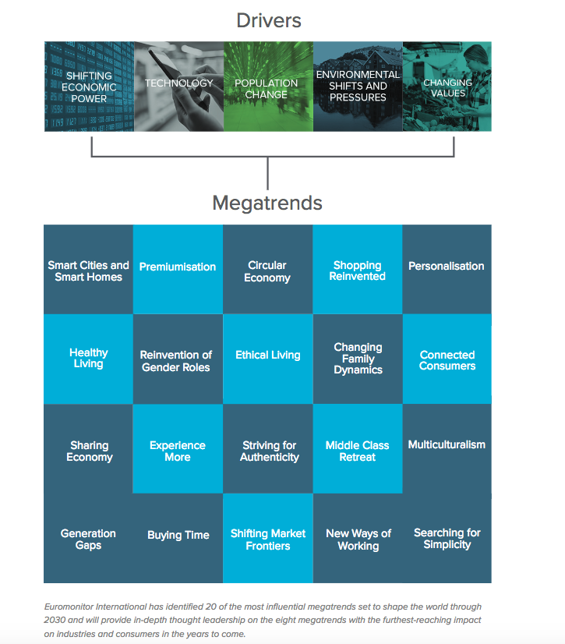 14

1. Beyond Shanghai: The age of urbanization 27

1. Individual empowerment 29

2. Diffusion of power 29

3. Demographic patterns 29

4. Growing demand for food, water, and energy 29

Disruptive tech trends 42

Digitization 42

Analytics 44

New micro/macro 44

Business 44

Macro Trends 70

Business operations 70

Customer Trends 73

Utility Trends 73

Disrupting Utilities-UK 73

Decentralization – DERs 76

Customer Segments – needs in the future. 77

Quantify what matters to your customers. 85

Company goals – alternate to road maps 92

roadmap vs gist 93

Goals 94

Goals -basic 97

Utility goals 100

SCE Customer choice 100

Grid modernization 101

Technology Initiatives 103

Ideation 104

Solutions 104

In-flight 109

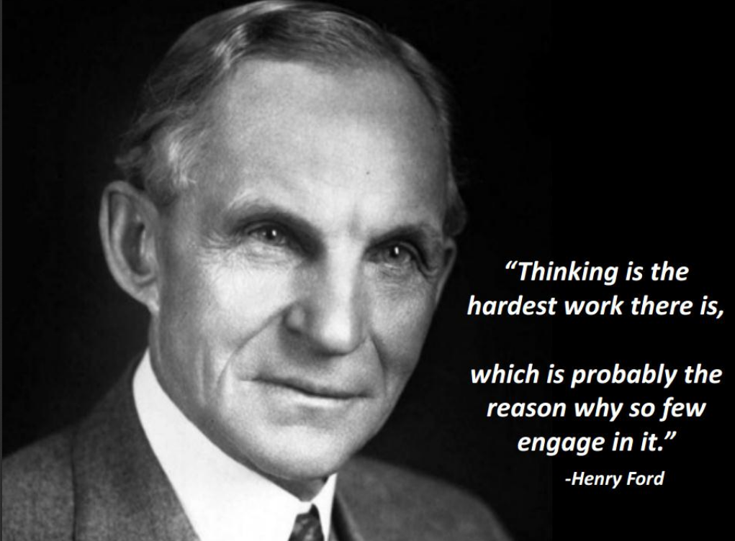

# Mega Trends – build into strategies

-TRACK TRENDS

<https://www.ted.com/talks/alison_sander_megatrends_the_art_and_science_of_trend_tracking>

PREDICTABLE

-Aging

-- age in place

- IoT

- entertainment & celebrity

- robotics

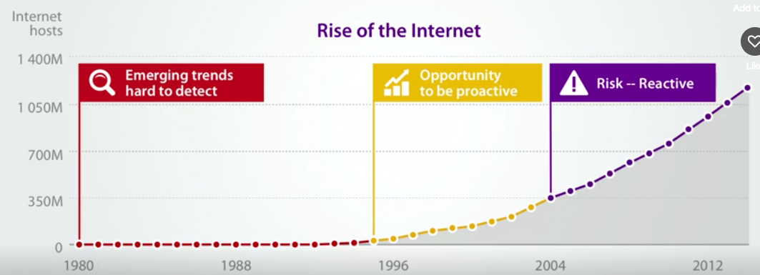

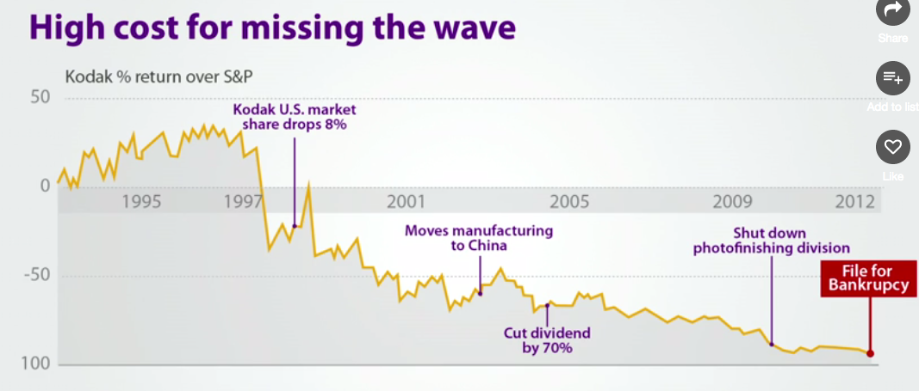

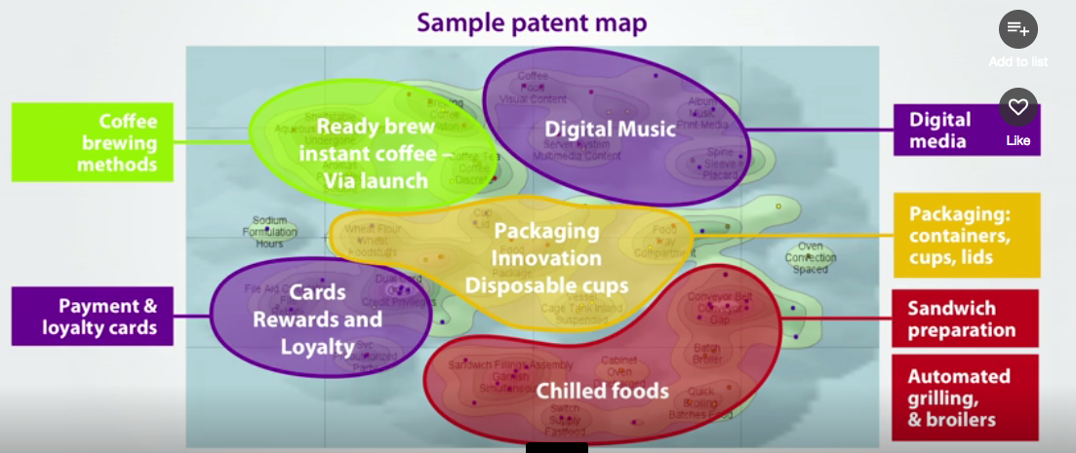

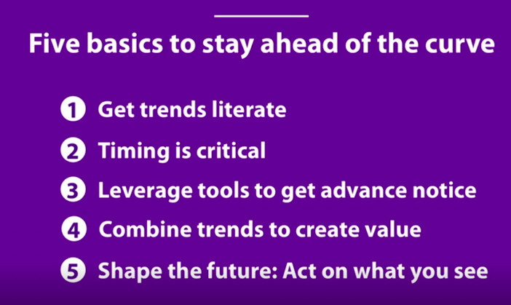

1. **Build a megatrend framework to guide innovation-**Establish these megatrends as the pillars against which you will evaluate all innovation projects / ideas.

2. **Develop tangible understanding that incites action-**who the trends attract and how they apply to your business

3. **Quantify impact and prioritize investment-**Identify key categories, products or consumer cohorts that can serve as a proxy for quantification. Approximate size, growth and projected impact of trends on your industry or category at the megatrend or trend level to rank and prioritise a wide set of consumer needs and identify those that will drive true value gains

4. **Evaluate your portfolio and pipeline to ensure success**

Map your current portfolio and innovation pipeline against the megatrend-driven needs of tomorrow for your consumers.

Identify gaps vs. key drivers of value gains to prioritise current projects and [identify whitespace innovation opportunities](https://blog.euromonitor.com/2017/01/how-to-identify-growth-opportunities-in-your-competitive-landscape-part-2-a-case-study.html).

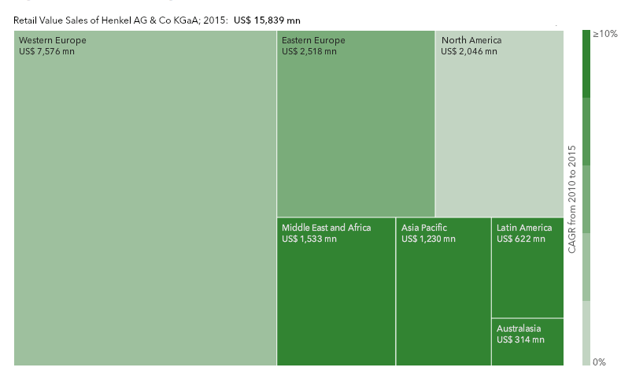

## **First step: Identify competitors**

By scanning across all possible country/category combinations available on [Passport market intelligence database](http://go.euromonitor.com/passport.html),

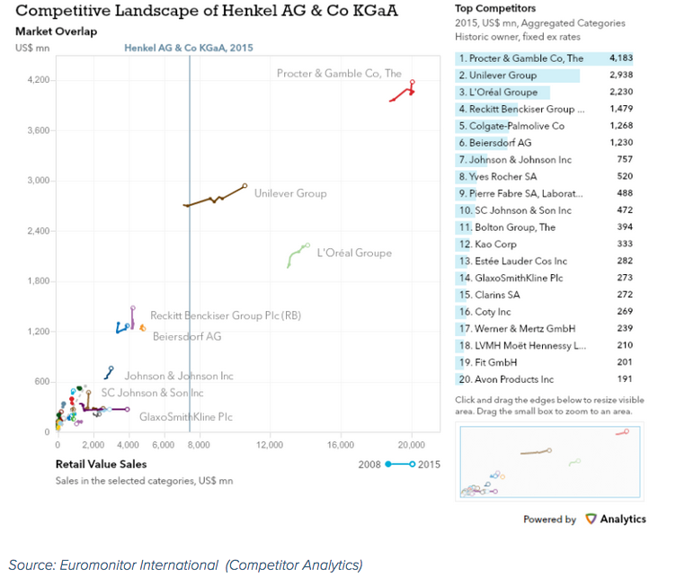

## **Second step: Examine each competitive pair in detail – and assess competitive footprints**

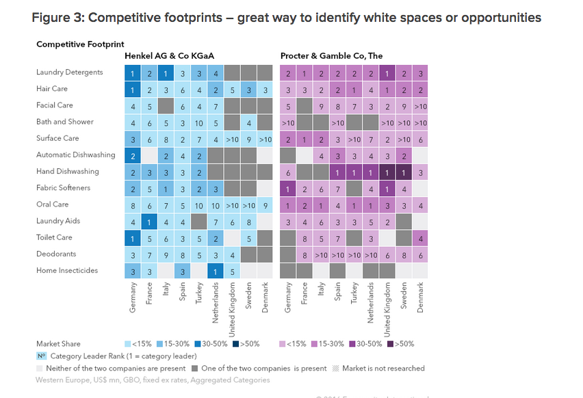

## **Third step: Classify opportunities into action areas**

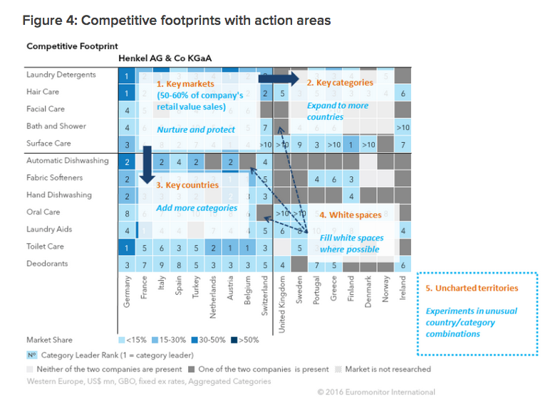

https://blog.euromonitor.com/2017/01/how-to-identify-growth-opportunities-in-your-competitive-landscape-part-2-a-case-study.html

## 5. **Repeat the process annually**

## Putting the customer at the heart of the analysis

http://go.euromonitor.com/rs/805-KOK-719/images/wpMegatrendAnalysis.pdf

Step 1: Define a “megatrend”

Step 2: Establish what is driving long-term

shifts in behaviour and attitudes

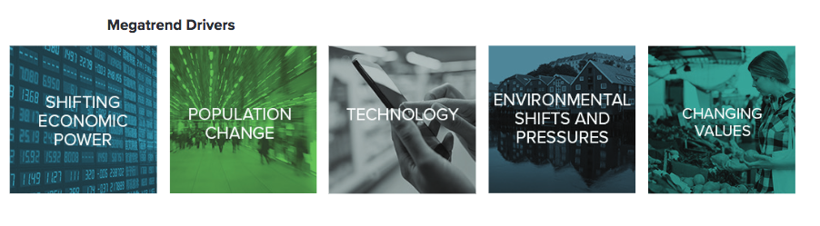

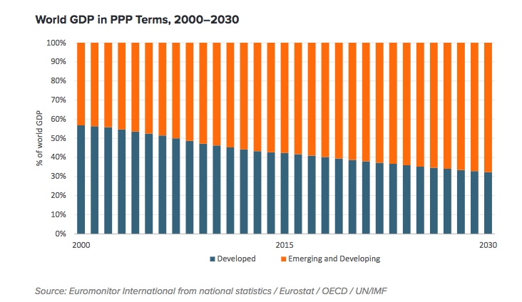

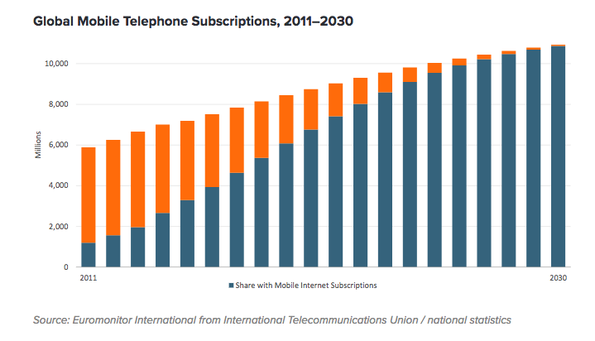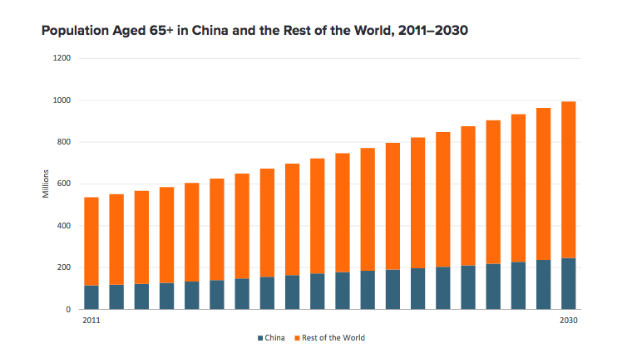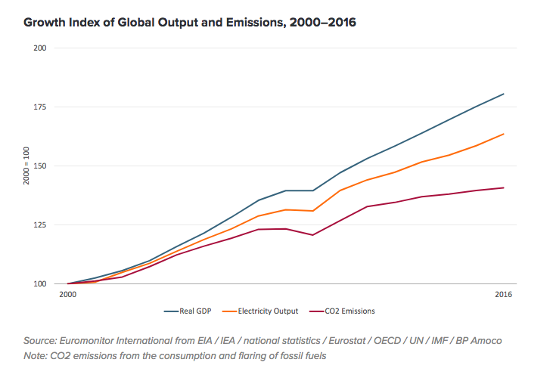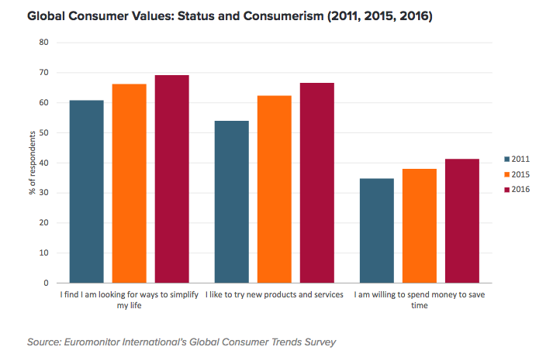

Step 3: Build an exhaustive list of

megatrends

DONE.

Megatrend analysis 

Step 4: pinpoint the megatrends which

matter most for your business

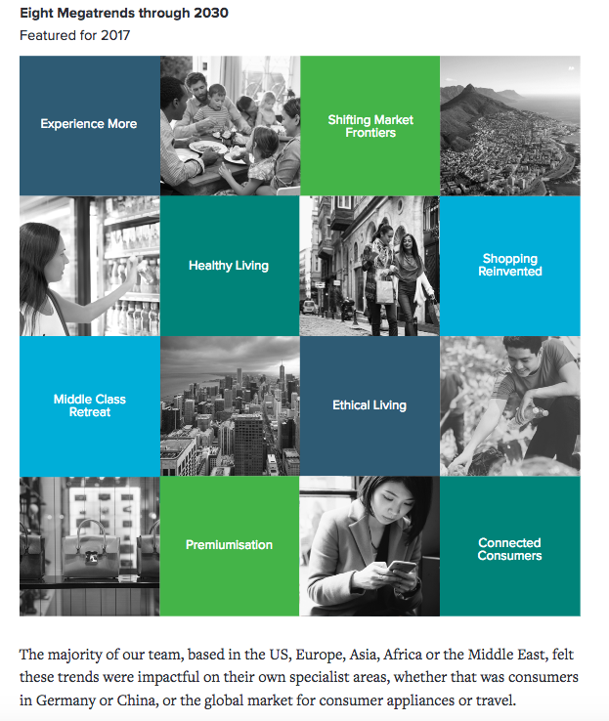

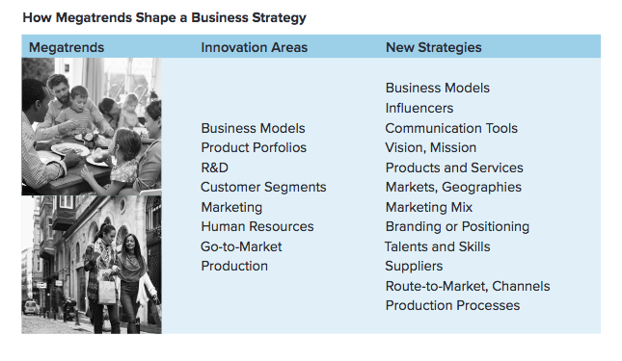

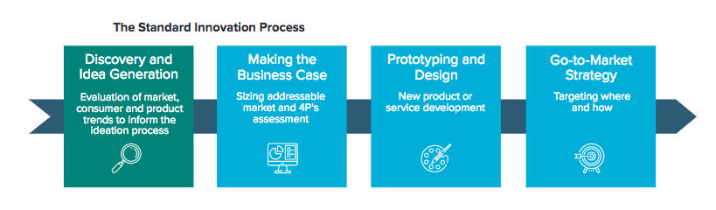

<http://go.euromonitor.com/rs/805-KOK-719/images/wpMegatrendAnalysis.pdf>

Step 1. Building of the initial definition of the mega-trend.

The first step starts with a brief description of the

methodology, which helps to set the starting point for the

researcher. The activities of step one are described in Table 1.

These activities include the identification of changing areas

of technology, how these technologies impulse the

megatrend, and the construction of a taxonomy, which will

help later to determine the areas that will be changing faster.

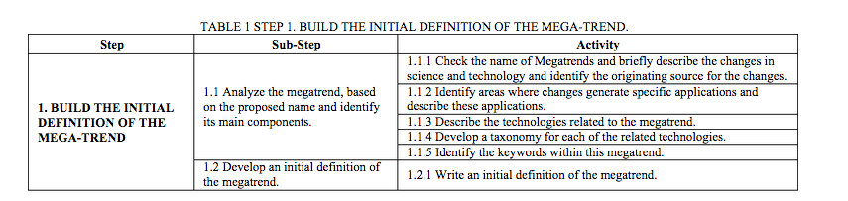

Step 2. Review important and relevant information about

the mega-trend.

The second step aims at reviewing important and relevant

information associated to the studied megatrend, as well as to

reviewing what some experts might think on the future. This

step is very important since most of researchers working on a

specific area; do not know much about foresight studies. This

literature review will help them to identify future behaviors,

also relevant to the development of the mega trend. The

review also aims at knowing the leading experts of the

technologies that are changing, classifies them and the

researcher will invite them at a validation round along with

other experts. The activities of step two are described in

Table 1 & Table 2.

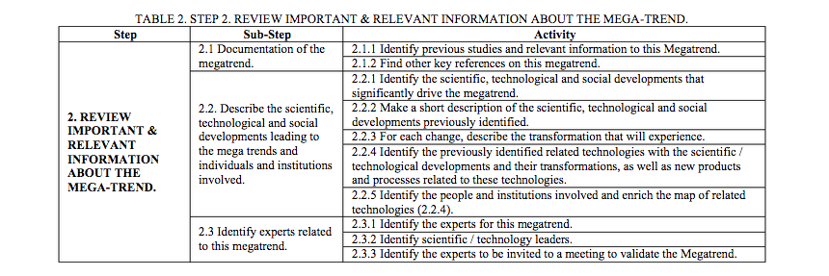  
Step 3. Development of the revised definition and internal

validation.

The third step seeks at including the information found in

step 2 into a brief report. Since a megatrend relates countless

types and sources of information, after a couple of steps, it is

necessary for the researcher to write down the findings and to

include relevant information as it is being found. The

activities of step three are described in Table 3. These

activities include at identifying the voluntary / involuntary

recipients of the megatrend, the work being performed at the

most recognized universities, growing areas of research,

types of project being funded by venture capital, identifying

the relevant emerging technologies, and the inclusion of these

findings into the report.

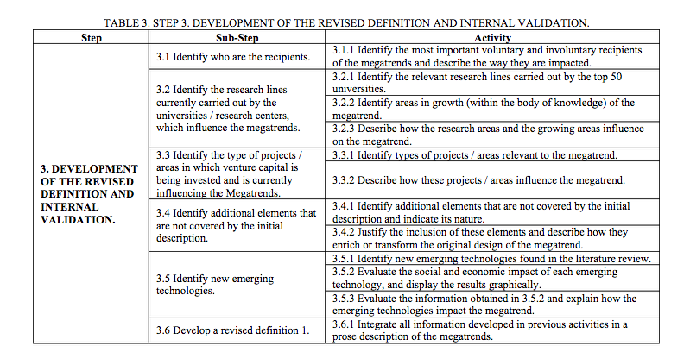  
Step 4. Finding the opportunities.

The fourth step continues with the purpose of the

methodology, to be able to find development opportunities.

First, the technologies are grouped using an affinity diagram.

The opportunities are found after identifying the challenges

faced by the related and emerging technologies – the

problems the technologies are facing such that they have not

been able to permeate the market. With these challenges, the

researcher needs to find the opportunities for each group of

technologies; the opportunities are then translated into

products and/or services that will allow the development of

the group of technologies. The activities of step four are

described in Table 4.

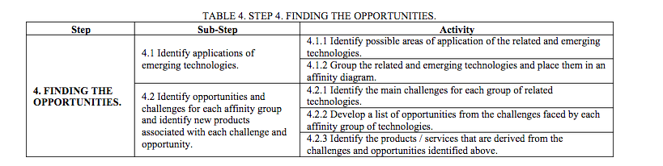

*PDF | Megatrend methodology to identify development opportunities*. Available from: <https://www.researchgate.net/publication/241162085_Megatrend_methodology_to_identify_development_opportunities> [accessed Jun 24 2018].

Step 5. Revised definition of megatrends and their

implications in terms of opportunities and products.

The fifth step continues with the integration of previous

information into the description of the megatrend. This

document will be passed out to a small group of experts who

will revise the document. A presentation will be developed

for the meeting where the results will be discussed. The

comments and the feedback for the obtained results are

included into the report and it is enriched. The activities of

step five are described in Table 5.

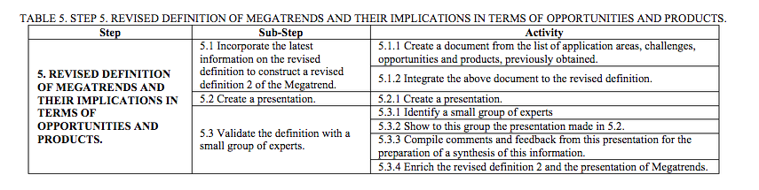

*PDF | Megatrend methodology to identify development opportunities*. Available from: <https://www.researchgate.net/publication/241162085_Megatrend_methodology_to_identify_development_opportunities> [accessed Jun 24 2018].

Step 6. Consultation and validation with panel of experts.

The sixth step consists on a second consultation and

validation to a larger group of experts. Since this

methodology was developed for different topics, and the

experts´ location was unknown, the researchers were given

different options, each with a set of templates that will let

them focus on the content only; the options were a meeting,

questionnaires and interviews. Once the consultation and the

validation were performed, the researcher incorporated

findings into the report. The activities of step six are

described in Table 6.

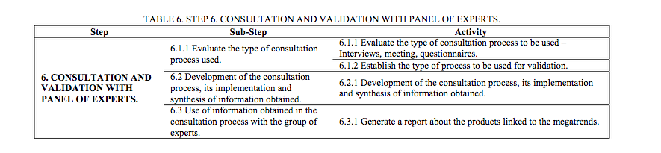

*PDF | Megatrend methodology to identify development opportunities*. Available from: <https://www.researchgate.net/publication/241162085_Megatrend_methodology_to_identify_development_opportunities> [accessed Jun 24 2018].

Step 7. Determination of commercial and technical

feasibility of products / services.

The seventh step consists on find out if there might be a

market for the identified products and services. If there is a

possible market for such products and services, then an

assessment is performed to determine if the conditions exist

to currently develop the product / service. If such conditions

do not exist yet, the researcher need to identify what needs to

be done to be able to produce the product/service in Mexico.

These findings are included into the final report. The

activities of step seven are described in Table 7.

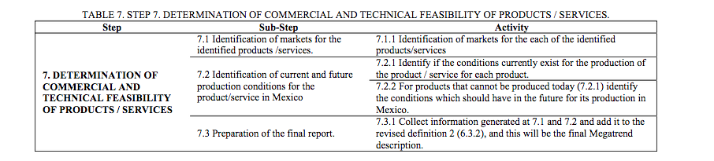

*PDF | Megatrend methodology to identify development opportunities*. Available from: <https://www.researchgate.net/publication/241162085_Megatrend_methodology_to_identify_development_opportunities> [accessed Jun 24 2018].

|  |  |  |  |  |  |  |  |  |  |  |  |  |  |  |  |
| --- | --- | --- | --- | --- | --- | --- | --- | --- | --- | --- | --- | --- | --- | --- | --- |
| **consonanace**  **Trends in demand, cost, and regulation; also input supplies, technologies** | |  |  |  |  |  |  |  |  |  |  |  |  |  |  |
| Understand what affects N, V and C |  |  |  |  |  |  |  |  |  |  |  |  |  |  |  |

4TH INDUSTRIAL REVOLUTION

<https://www.weforum.org/videos/the-fourth-industrial-revolution>

NANOTECH,BRAIN RESEARCH, 3D PRINTING, MOBILE NETWORKS, COMPUTING

##### Short-term opportunities: Operational efficiency

##### Short-term opportunities: New products and services

##### Long-term opportunities: Outcome economy

##### Long-term opportunities: Autonomous economy

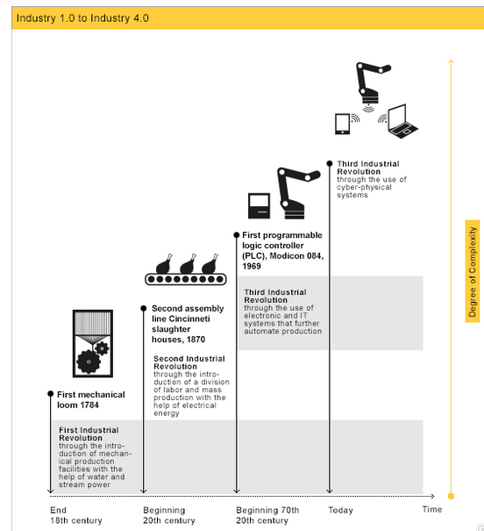

NDUSTRIE 4.0 represents a paradigm shift from "centralized" to "decentralized" production - made possible by technological advances which constitute a reversal of conventional production process logic. Simply put, this means that industrial production machinery no longer simply “processes” the product, but that the product communicates with the machinery to tell it exactly what to do.

Highly individualized, low-volume, real-time production becomes the norm as new industrial assistant systems allow new forms of machine-human production in a changing industry landscape.

https://www.gtai.de/GTAI/Navigation/EN/Invest/Industries/Industrie-4-0/Industrie-4-0/industrie-4-0-what-is-it.html#1798434

EIGHT MEGATRENDS

THROUGH 2030

<http://go.euromonitor.com/rs/805-KOK-719/images/wpMegatrendAnalysis.pdf>

“Middle class retreat”

The “Middle Class Retreat” megatrend asserts that whilst the middle classes boom

in Asia, the middle classes in developed markets struggle to maintain the economic

position they enjoyed for the last half a century. This is exemplified by the growth of

discounters in grocery retailing.

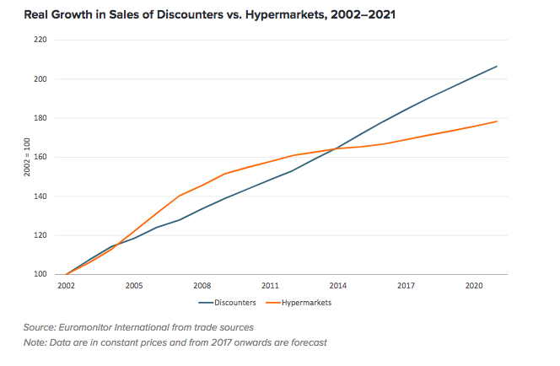

“Experience More”

Another shift in behaviour is the increased emphasis on experiences over possessions.

We can see the sharp divergence in trends following the global financial crisis when

real growth in spending on durable goods fell and spending on services continued to

grow.

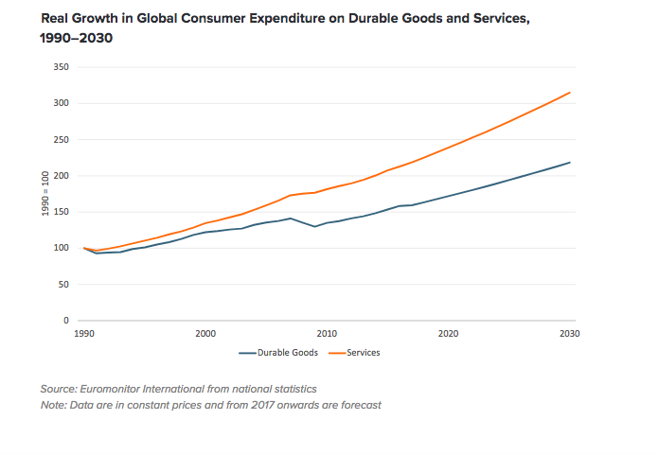

“Shifting Market frontiers”

As some areas of the globe become over-farmed, over-populated, or otherwise reach

their maximum potential, others gain prominence for their unexploited potential. We

call this megatrend “Shifting Market Frontiers”. To ensure future growth, businesses

will have to adapt to the changing demographic, economic and technological reality

bringing new markets from frontier into the spotlight. China is a case in point, with

market saturation and competition intensifying in China’s major cities, businesses

must shift their interest to fast growing mid-sized cities. Rising business investment,

increasing disposable incomes, better infrastructure and the growing adoption of

high-speed internet have laid the foundations for mid-sized city growth in China

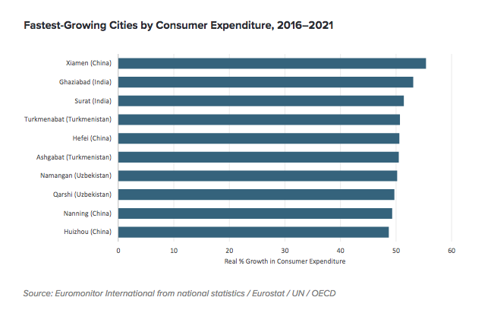

“premiumisation”

“Premiumisation” is another of our focus megatrends, whilst many will see this as

nothing new, what has changed is the motivation behind consumers’ purchasing

decisions. At its core, premiumisation is about

priorities

. With more products available

at more price points than ever before, consumers can spend more on the things that

matter to them, while cutting back—often significantly—on those that do not.

splurge on their pets

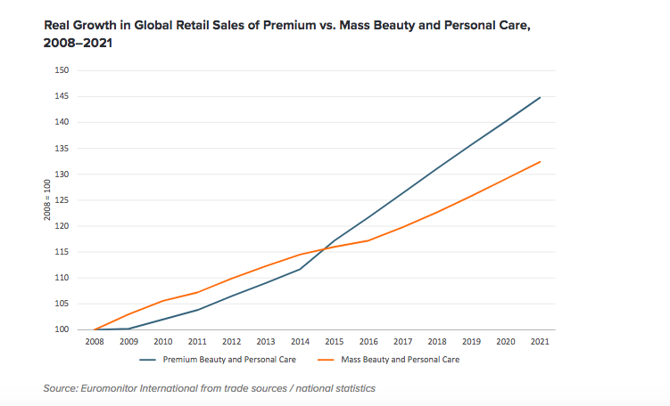

“Shopping reinvented”How we buy goods and services is constantly in flux as

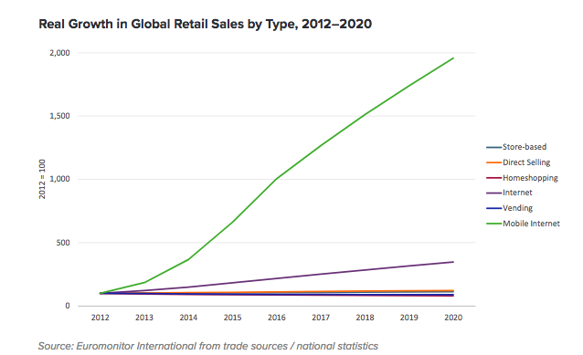

“Healthy living”

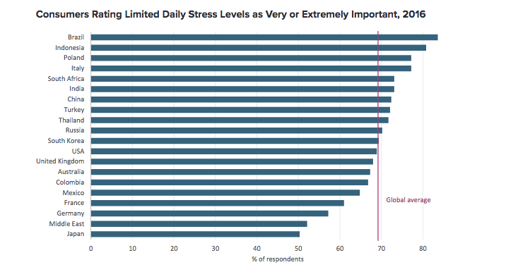

“connected consumers

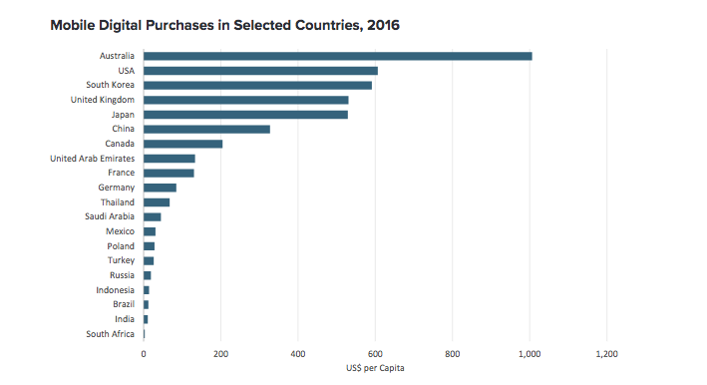

SARAH BOUMPHREY

Director, Economies and consumers

Euromonitor International, uK

[View transcript](https://www.pwc.co.uk/issues/megatrends/5-global-shifts.html)

<https://www.mckinsey.com/business-functions/strategy-and-corporate-finance/our-insights/the-four-global-forces-breaking-all-the-trends>

## 1. Beyond Shanghai: The age of urbanization

The tip of the iceberg: Accelerating technological change

Getting old isn’t what it used to be: Responding to the challenges of an aging world

Trade, people, finance, and data: Greater global connections

* [[](https://www.pwc.co.uk/issues/megatrends.html#tab_5-0)Rapid urbanisation](https://www.pwc.co.uk/issues/megatrends.html#tab_5-0)
* [[](https://www.pwc.co.uk/issues/megatrends.html#tab_5-1)Climate change and resource scarcity](https://www.pwc.co.uk/issues/megatrends.html#tab_5-1)
* [[](https://www.pwc.co.uk/issues/megatrends.html#tab_5-2)Shift in global economic power](https://www.pwc.co.uk/issues/megatrends.html#tab_5-2)
* [[](https://www.pwc.co.uk/issues/megatrends.html#tab_5-3)Demographic and social change](https://www.pwc.co.uk/issues/megatrends.html#tab_5-3)
* [[](https://www.pwc.co.uk/issues/megatrends.html#tab_5-4)Technological breakthroughs](https://www.pwc.co.uk/issues/megatrends.html#tab_5-4)

<https://www.pwc.co.uk/issues/megatrends.html>

## 1. Individual empowerment

## 2. Diffusion of power

## 3. Demographic patterns

## 4. Growing demand for food, water, and energy

demand for food, water, and energy will rise by approximately 35, 40, and 50% respectively

* Globalization 2.0 – a new world order is emerging as economic power shifts to Asia
* Environmental crisis – leaders must embed sustainable cultures as critical natural resources run out
* Individualism – smart employers will design ways of working to suit individuals in order to retain talent
* Digitization - in a climate of transparency, leaders must display high standards of integrity and sincerity
* Demographic change - an aging population means a shrinking global workforce, chronic skills shortages and a fierce war for talent
* Technological convergence - the convergence of nano, bio, information and cognitive sciences will generate untold new product markets, and make others obsolete.

<https://www.haygroup.com/en/campaigns/the-six-global-megatrends-you-must-be-prepared-for/>

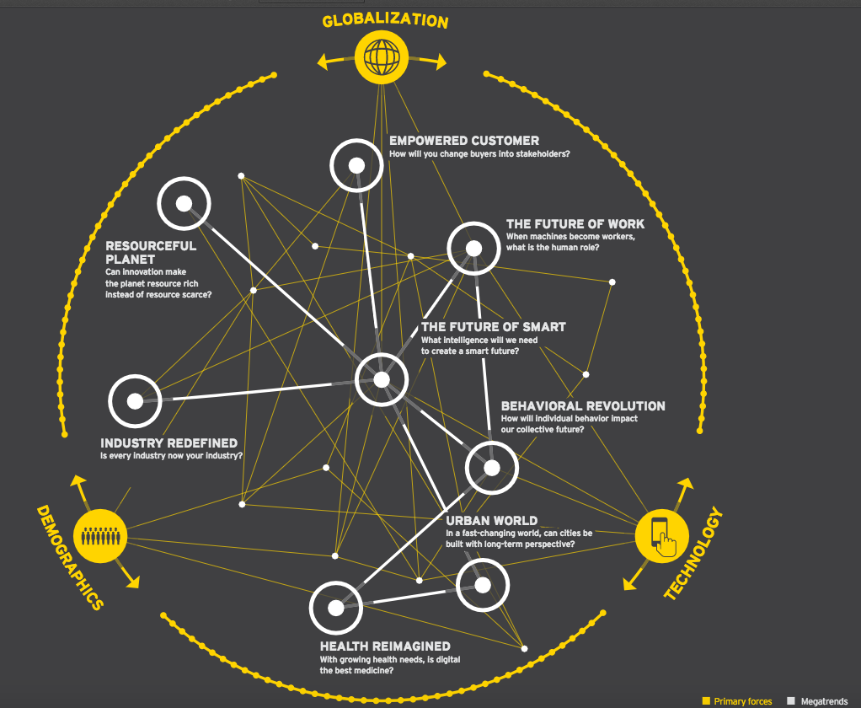

**Technology** – Advances in technology have been disrupting business models for centuries. In our lifetime, successive waves of the IT revolution (PC, online, mobile, social) have democratized data, empowered consumers and spawned scores of new industries. The next waves – the Internet of Things (IoT), virtual reality, AI, robotics – promise to be even more revolutionary.

**Globalization** – Thanks to trade liberalization and emerging market growth, globalization has accelerated in recent decades. These trends disrupt existing business models by creating new competitors, reordering supply chains and lowering price points. The next waves – including the emergence of Africa and a more multipolar world – will increase complexity and require flexible business models to respond to global shifts.

**Demographics** – In the decades ahead, relatively high birth rates will make Africa and India engines of economic opportunity. Aging populations will transform everything from health care to real estate, while millennial-dominated workforces will reinvent the workplace.

1. Industry redefined

2.

The future of smart

-By improving access to and management of resources, smart can help to improve provision for underserved populations and communities

-Mitigating different forms of risk is made easier through smart, whether it’s the detection of fraud or preventing network failures in various systems from energy grids to production lines.

-Stakeholders will see different outcomes from smart. Some will see increased efficiencies and reduced costs, while others will see improvements in outcomes such as more accurate medical diagnosi

-Investments in smart have ancillary and far-reaching benefits.Smart grids raise the stakes in infrastructure and enhance market competition as well as a market’s competitiveness.

-Smart is a differentiator that adds competitive advantages. It enables better, more efficient and more agile use of existing assets.

3.

The future of work

Moving from the gig economy to the machine economy-reduce errors and problems

-efficiency and productivity

-unlease wave of entrepuership

-nimbel regulation based on needs

4.

Behavioral revolution

Society benefits from minimizing the

impact of looming collective-action

crises, such as chronic disease and

climate change

Governments avert

the fiscal impact of

these potential crise

ndividuals lead healthier lives and have

healthier savings

5.

Empowered customer

Treating customers as stakeholders rather

than buyers generates a virtuous cycle —

customers benefit from better products and

services and companies are more likely to

meet their needs

Co-creation gets

customers invested in

the success of an idea

and builds loyalty —

even evangelism.

From maker spaces to crowdfunding

to invention platforms, there are more

ways than ever to get an idea

off the ground.

Empowered customers

carry their rights

with them into other

domains. Empowered

citizens help

governments to become

more transparent and

responsive, boosting

efficiencies and helping

to achieve policy goals

Delivering rich

experiences — either

wrapped around products

or services or standalone

— has the potential to

improve margins and

create new revenue

stream

6.

Urban world

New cities are being

built from the ground up

Dense living

cities smart and resilient is a

trillion-dollar opportunity f

pioneering

the sharing economy,

green architecture,

microgrids, driverless

transport and mor

7.

Health reimagined

8.

Resourceful planet

[***The great eight: Trillion-dollar growth trends to 2020***](http://www.bain.com/publications/articles/eight-great-trillion-dollar-growth-trends-to-2020.aspx)

|  |  |  |
| --- | --- | --- |
| **Trends** | **Description** | **Analytics** |
| [***The next billion consumers***](http://www.bain.com/publications/articles/the-next-billion-consumers.aspx) | [Big demand is coming on line, but the emerging market "middle class" will be poorer overall.](http://www.bain.com/publications/articles/the-next-billion-consumers.aspx) | **Customer Intelligence Analytics, Market analytics** |
| [***Old infrastructure, new investments***](http://www.bain.com/publications/articles/old-infrastructure-new-investments.aspx) | [Urbanization in developing nations and obsolescence in developed nations will spur infrastructure spending.](http://www.bain.com/publications/articles/old-infrastructure-new-investments.aspx) | **Estimating, New Projects, Optimization** |
| [***Militarization following industrialization***](http://www.bain.com/publications/articles/militarization-following-industrialization.aspx) | [A transient opportunity for defense contractors.](http://www.bain.com/publications/articles/militarization-following-industrialization.aspx) |  |
| [***Growing output of primary inputs***](http://www.bain.com/publications/articles/growing-output-of-primary-inputs.aspx) | [Increased demand for basic commodities](http://www.bain.com/publications/articles/growing-output-of-primary-inputs.aspx) | **Optimization** |
| [***Developing human capital***](http://www.bain.com/publications/articles/developing-human-capital.aspx) | [Investments in workforce training will be required to lift skill levels in new markets and to remain competitive in developed ones.](http://www.bain.com/publications/articles/developing-human-capital.aspx) | **Demand for Analytical skills increasing** |
| [***Keeping the wealthy healthy***](http://www.bain.com/publications/articles/keeping-the-wealthy-healthy.aspx) | [Healthcare spending will continue to grow, but at slower rates.](http://www.bain.com/publications/articles/keeping-the-wealthy-healthy.aspx) | **Healthcare Analytics** |
| [***Everything the same, but nicer***](http://www.bain.com/publications/articles/everything-the-same-but-nicer.aspx) | [For the affluent, the search for quality improvement rather than quantity will drive consumption trends](http://www.bain.com/publications/articles/everything-the-same-but-nicer.aspx) | **Product Positioning** |
| [***Prepping for the next big thing***](http://www.bain.com/publications/articles/prepping-for-the-next-big-thing.aspx) | [The next platform breakthrough isn't here yet, but the seeds are beginning to sprout.](http://www.bain.com/publications/articles/prepping-for-the-next-big-thing.aspx) | **Forecasting Customer Needs and Wants** |

|  |  |  |
| --- | --- | --- |
| **Trends** | **Description** | **Analytics** |
| **Digital future** | **Technology disruption fueled by technology convergence and demand for anytime access to information** | Social, mobile, cloud and big data analytics |

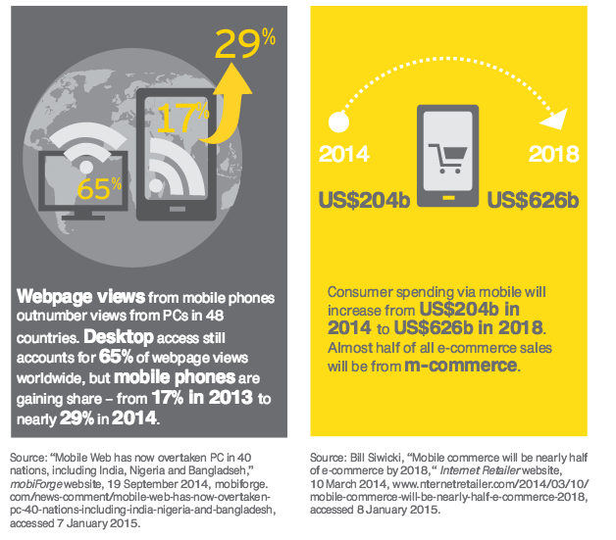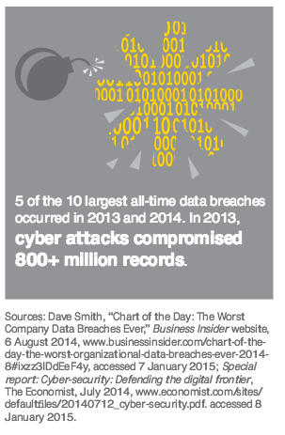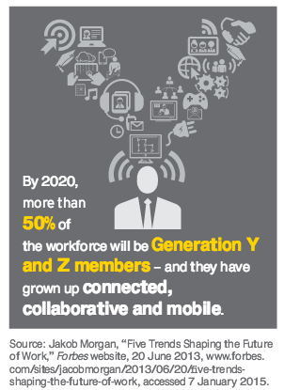

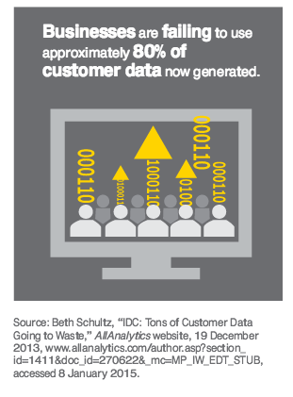



|  |  |  |
| --- | --- | --- |
| **Trends** | **Description** | **Analytics** |
| **Entrepreneurship rising** | Entrepreneurship around the world is growing, driving the need for more supportive ecosystems, enabling machines and software to substitute for humans.  High-impact entrepreneurs are building innovative and scalable enterprises that capitalize on local needs  **Many of these new enterprises are digital from birth.** | **Analytics as a core competency (Digital DNA)**  **Machines – Predictive Analytics (Computer Vision, etc)** |

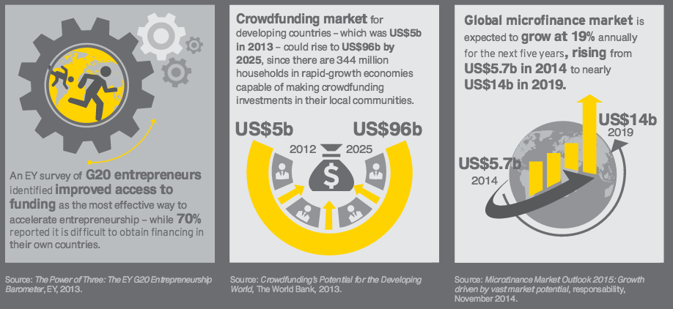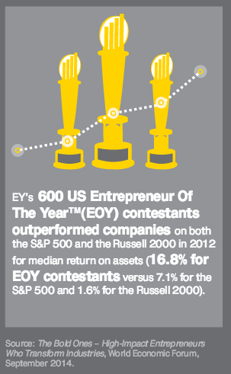

|  |  |  |
| --- | --- | --- |
| **Global Marketplace** | **Economic power continues to shift east and south, driving new patterns of trade and investment.**  **A new tier of emerging nations, driven by their own nascent**  **middle classes, will draw global attention.**  **Economic power continues to shift east and south, driving new patterns of trade and investment** | **Customer Intelligence scope increasing on a global scale, and using the web** |

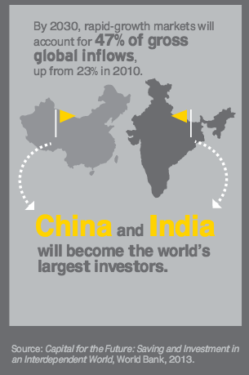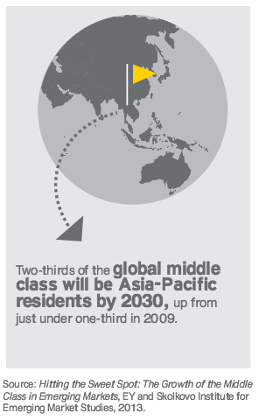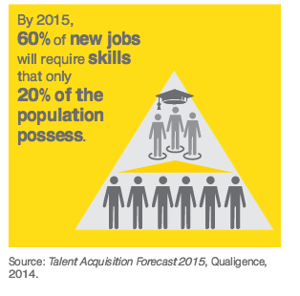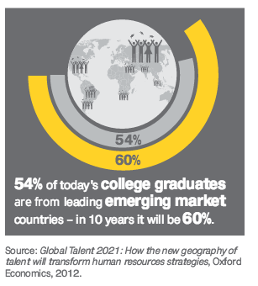

|  |  |  |
| --- | --- | --- |
| Trends | Description | Analytics |
| Urban world | Effective infrastructure investment and sound planning will make future  cities competitive and resilient  The United Nations (UN) reports that 54% of the world’s population  currently live in cities, and by 2050, this proportion will increase to 66%. | Domain knowledge areas: Urban |

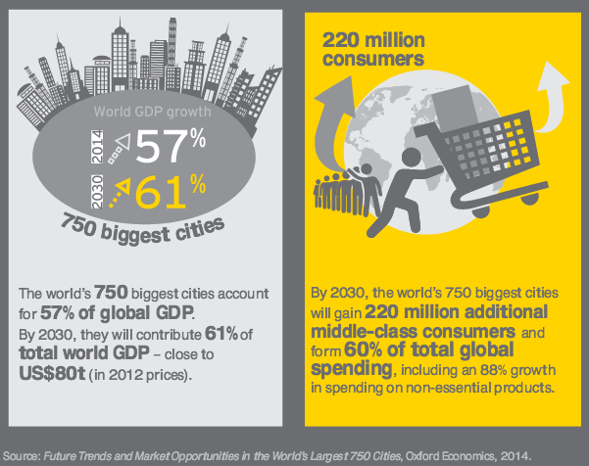

|  |  |  |
| --- | --- | --- |
| **Trends** | **Description** | **Analytics** |
| **Resourceful planet** | Absolute population growth, economic development and more middle-class consumers will drive increasing global demand for natural resources. Growing demand and shifting supply are driving innovation in the energy and resources space natural resources must be more effectively managed, particularly from an environmental impact perspective. | **Optimizing production efficiency (Prescriptive Analytics)** |

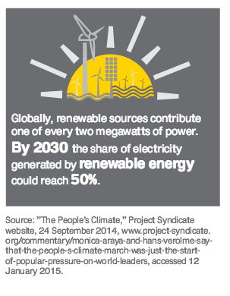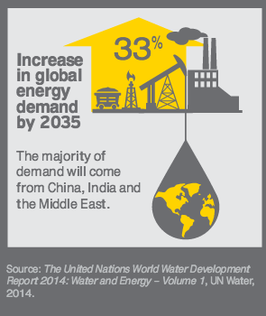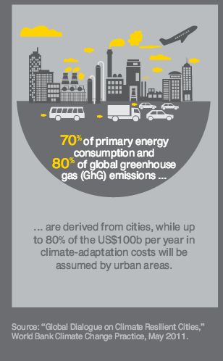

|  |  |  |
| --- | --- | --- |
| **Healthcare reimagined** | **Technology and demographics converge to drive a once-in-a-lifetime transformation**  **Health care — which already accounts for 10% of global GDP — is embarking**  **on a once-in-a-lifetime transformation.**  **An explosion in big data and mobile health technologies is enabling real-time information creation and analysis.** | **Health Care Analytics (Domain)** |

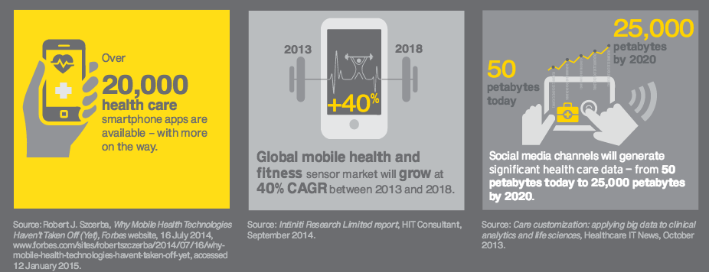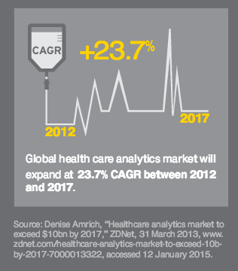

**Business Technology Trends (Accenture)**

|  |  |  |
| --- | --- | --- |
| **Trends** | **Description** | **Analytics (Examples)** |
| Internet of Me | - **Success =** deliver the **individual experiences** that consumers demand  - Shift from **mobility to the Internet of Things (IoT)** | Learning customer preferences  (Predictive analytics)  ***- Human-centered health***  ***- Events – personalized ads***  ***- Auto/Home - thermostat***  ***- Recommendation systems***  ***- Home – energy scheduling***  ***- Auto - driver’s habits*** |
| Outcome Economy | **- From selling products to selling results**  - more meaningful outcomes  (drill-bits vs holes-outcome) | - **Streetline** Smart Parking meter Ap (logistics, forecasting analytics)  - **Uber** (transportation, forecasting, optimization)  Manufacturing (agriculture, forecasting, optimization) |
| Workforce re-imagined | -Technology to interact as a team member  - **People and machines effectively work as a collaborative team** (competitive edge) | robots to work together with humans (safety)  **LA Times QuakeBot** |
| Trends | Description | Analytics (Examples) |
| Platform Revolution | - In 2013, 14 of the top 30 global brands by market capitalization were platform-oriented companies (MIT)  - Advances in social, mobile, analytics, cloud (Microsoft’s Azure, Amazon Web Services, Force.com), M2M/Internet of Things (IoT) and application  (APIs), open-source software | Analytics driven platforms:  MyJohnDeere, GE PredixTM  Philips HealthSuite  Kaiser Interchange  London Heathrow Airport  Pegasystems’, Netflix |
| Intelligence Enterprise | 2020, there will be more than 40 zetabytes of data, 37 percent of which will be considered useful for analysis.  Software Intelligence: Advances in data science | Analytics, Advanced Analytics, Cognitive Analytics, AI    Google/Yahoo Bing Spam filters & Search  IPsoft (guarantee 30% IT efficiency increase in 90 days)  6Sense (80% accuracy –propensity to buy) |

More

|  |  |  |
| --- | --- | --- |
| **“Maker Movement”** |  | **More competition, Competing on Analytics** |
| Commoditization | Traditional sources of competitive advantage disappear (eg. Knowledge) | **Analytics as a core competency** |
| Internet of Things | 3rd Industrial Revolution: internet technology and renewable energy (Jeremy Rifkin)  -Industrial Internet of Things (IIOT) | **(Geo-Analytics, Predictive Analytics/ Machine Learning, Optimization)**  ***GE’s “Industrial Internet,”***  ***Cisco’s “Internet of Things,”***  ***IBM's "Smarter Planet,"***  ***Siemen's "Sustainable Cities”*** |
| Blurring Industry boundaries |  | **Data-driven Products** (***Amazon Studios*** – uses movie data to develop movie requirements) |
| Changing Regulations | HealthCare | **Healthcare Analytics** |
| Information Overload |  |  |

|  |  |  |  |  |  |  |  |  |  |  |  |  |  |  |  |  |  |  |  |  |  |  |  |  |  |  |  |  |  |  |  |  |  |  |  |  |  |  |  |  |  |  |  |
| --- | --- | --- | --- | --- | --- | --- | --- | --- | --- | --- | --- | --- | --- | --- | --- | --- | --- | --- | --- | --- | --- | --- | --- | --- | --- | --- | --- | --- | --- | --- | --- | --- | --- | --- | --- | --- | --- | --- | --- | --- | --- | --- | --- |
| Strengthened | |  | |  | |  | | | | | | | | | | |  | |  | |  | |  | |  | |  | | |  |  | | |  | | | | | | |  |  | |
| The rise of RDE companies as competitors and partners: outsourcing and offshoring, captial flows to RDEs, The rise of RDE challengers, | | Strengthened – | |  |  | | |  |  | |  |  | |  | | | | | | | | | | | | | |  | | | |  | | |
| Online migration – E-commerce, the rise on online communities, new media, | | Strengthened – | |  |  | | |  |  | |  |  | |  | | | | | | | | | | | | | |  | | | |  | | |
| Trading down | | Strengthened – | |  |  | | |  |  | |  |  | |  | | | | | | | | | | | | | |  | | | |  | | |
| Technology – mobile communications, bandwidth and access, convergence | | Strengthened – | |  |  | | |  |  | |  |  | |  | | | | | | | | | | | | | |  | | | |  | | |
| Anxiety – identity theft, th rise of counterfiet brands, lost of trust in institutions. | | Strengthened – | |  |  | | |  |  | |  |  | |  | | | | | | | | | | | | | |  | | | |  | | |
| Techno wonderland "everything" | | Strengthened – | |  |  | | |  |  | |  |  | |  | | | | | | | | | | | | | |  | | | |  | | |
| Connected - Always connected "digital" | | Strengthened – | |  |  | | |  |  | |  |  | |  | | | | | | | | | | | | | |  | | | |  | | |
| Speed Economy | | Strengthened – | |  |  | | |  |  | |  |  | |  | | | | | | | | | | | | | |  | | | |  | | |
| Mass Niche not mass groups | | Strengthened – | |  |  | | |  |  | |  |  | |  | | | | | | | | | | | | | |  | | | |  | | |
| Universal Values | | Strengthened – | |  |  | | |  |  | |  |  | |  | | | | | | | | | | | | | |  | | | |  | | |
| Self-Actualization frontier increasing - Personal Design | | Strengthened – | |  |  | | |  |  | |  |  | |  | | | | | | | | | | | | | |  | | | |  | | |
| Aging population | | Strengthened – | |  |  | | |  |  | |  |  | |  | | | | | | | | | | | | | |  | | | |  | | |
| The creative class | | Strengthened – | |  |  | | |  |  | |  |  | |  | | | | | | | | | | | | | |  | | | |  | | |
| Corporate Technologies in the hand of Citizens | | Strengthened – | |  |  | | |  |  | |  |  | |  | | | | | | | | | | | | | |  | | | |  | | |
| Female Empowerment | |  | |  |  | | |  |  | |  |  | |  | | | | | | | | | | | | | |  | | | |  | | |
|  | |  | |  |  | | |  |  | |  |  | |  | | | | | | | | | | | | | |  | | | |  | | |
| Continued Growing | |  | |  |  | | |  |  | |  |  | |  | | | | | | | | | | | | | |  | | | |  | | |
| The rise of RD consumers: the rise fo the middle class, next billion consumers; | | Continued growing – | |  |  | | |  |  | |  |  | |  | | | | | | | | | | | | | |  | | | |  | | |
| Demographic trends: aging populations, obesity and dieting, | | Continued growing – | |  |  | | |  |  | |  |  | |  | | | | | | | | | | | | | |  | | | |  | | |
| Urbanization – by 2050 More than 75% will be urbanites | | Continued growing – | |  |  | | |  |  | |  |  | |  | | | | | | | | | | | | | |  | | | |  | | |
| Resource ontraints – corporate social responsibility, waste and waste management, | | Continued growing – | |  |  | | |  |  | |  |  | |  | | | | | | | | | | | | | |  | | | |  | | |
| Technology – nanotechnology, cloud computing, smart devices, | | Continued growing – | |  |  | | |  |  | |  |  | |  | | | | | | | | | | | | | |  | | | |  | | |
| Technology - Cloud computing.  “e-migration”—the movement of customers and companies to online channels. Web applications that allow dynamic user participation, social interaction, and collaboration has been growing, and innovative business models are starting to emerge. | |  | |  |  | | |  |  | |  |  | |  | | | | | | | | | | | | | |  | | | |  | | |
| Health and wellness trends – organic products, sports and fitness, biotechnology, nutraceuticals, | | Continued growing – | |  |  | | |  |  | |  |  | |  | | | | | | | | | | | | | |  | | | |  | | |
| Physical is increasingly virtual | | Continued growing – | |  |  | | |  |  | |  |  | |  | | | | | | | | | | | | | |  | | | |  | | |
| Manufacturing shifting around the globe | | Continued growing – | |  |  | | |  |  | |  |  | |  | | | | | | | | | | | | | |  | | | |  | | |
| Global Warming | | Continued growing – | |  |  | | |  |  | |  |  | |  | | | | | | | | | | | | | |  | | | |  | | |
| Socially responsible increasing for corporate | | Continued growing – | |  |  | | |  |  | |  |  | |  | | | | | | | | | | | | | |  | | | |  | | |
| Global Sustainers "Sustainability" | | Continued growing – | |  |  | | |  |  | |  |  | |  | | | | | | | | | | | | | |  | | | |  | | |
| Caring companies | | Continued growing – | |  |  | | |  |  | |  |  | |  | | | | | | | | | | | | | |  | | | |  | | |
| Doing more with less | |  | |  |  | | |  |  | |  |  | |  | | | | | | | | | | | | | |  | | | |  | | |
|  | |  | |  |  | | |  |  | |  |  | |  | | | | | | | | | | | | | |  | | | |  | | |
| **“Asian ascent”** —the growth of China and India. | | Power clusters | |  |  | | |  |  | |  |  | |  | | | | | | | | | | | | | |  | | | |  | | |
| **New economies** | | Power clusters | |  |  | | |  |  | |  |  | |  | | | | | | | | | | | | | |  | | | |  | | |
| **Cloud computing** | | Power clusters | |  |  | | |  |  | |  |  | |  | | | | | | | | | | | | | |  | | | |  | | |
|  | |  | |  |  | | |  |  | |  |  | |  | | | | | | | | | | | | | |  | | | |  | | |
| Emerging | |  | |  |  | | |  |  | |  |  | |  | | | | | | | | | | | | | |  | | | |  | | |
| Emerging market debt spreads moving in tandem with developed countries | | Emerging | |  |  | | |  |  | |  |  | |  | | | | | | | | | | | | | |  | | | |  | | |
| Creative Capital | | Emerging | |  |  | | |  |  | |  |  | |  | | | | | | | | | | | | | |  | | | |  | | |
| Downsizing non-growth entities | | Emerging | |  |  | | |  |  | |  |  | |  | | | | | | | | | | | | | |  | | | |  | | |
| Connected - C2C more powerful than C2B communication | | Emerging | |  |  | | |  |  | |  |  | |  | | | | | | | | | | | | | |  | | | |  | | |
| Connected - Brand Invasion | | Emerging | |  |  | | |  |  | |  |  | |  | | | | | | | | | | | | | |  | | | |  | | |
| Convenienc Technology - Broadcast control is not self scheduled | | Emerging | |  |  | | |  |  | |  |  | |  | | | | | | | | | | | | | |  | | | |  | | |
| Rethinking Energy | | Emerging | |  |  | | |  |  | |  |  | |  | | | | | | | | | | | | | |  | | | |  | | |
|  | |  | |  |  | | |  |  | |  | |  | |  |  | |  | | | | | | | | | | | | | | | | |  | | |  | |
| US Issues | |  | |  |  | | |  |  | |  | |  | |  |  | |  | | | | | | | | | | | | | | | | |  | | |  | |
| Public finances | | US Issues | |  |  | | |  |  | |  | |  | |  |  | |  | | | | | | | | | | | | | | | | |  | | |  | |
| Infrastructure | | US Issues | |  |  | | |  |  | |  | |  | |  |  | |  | | | | | | | | | | | | | | | | |  | | |  | |
| Clogged credit markets | | US Issues | |  |  | | |  |  | |  | |  | |  |  | |  | | | | | | | | | | | | | | | | |  | | |  | |
| High unemployment | | US Issues | |  |  | | |  |  | |  | |  | |  |  | |  | | | | | | | | | | | | | | | | |  | | |  | |
|  | |  | |  |  | | |  |  | |  | |  | |  |  | |  | | | | | | | | | | | | | | | | |  | | |  | |
| Trade flows, war for talent, m&A, financial innovation, trading-up, wealth disparities. | | Trending down | |  |  | | |  |  | |  | |  | |  |  | |  | | | | | | | | | | | | | | | | |  | | |  | |
| Austerity | | not-sustaining | |  |  | | |  |  | |  | |  | |  |  | |  | | | | | | | | | | | | | | | | |  | | |  | |
| Globalization | | Industry Blurring | |  | |  | | | | | | | | | | |  | |  | |  | |  | |  | |  | | |  |  | | |  | | | | | | |  |  | |
|  |  | |  | | | |  | | |  | | | | | | | | | |  | |  | |  | |  | | |  | | | |  | | |  |  | |  | | | |  | |  |



AJames/Calstatela

[http://www.bain.com/publications/business-insights/eight-grWat-macro-trends.aspx](http://www.bain.com/publications/business-insights/eight-great-macro-trends.aspx)

# Disruptive tech trends

## Digitization

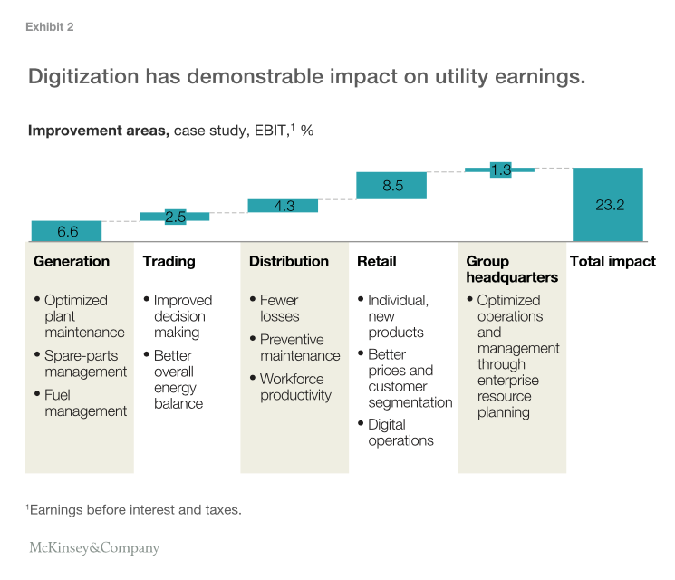

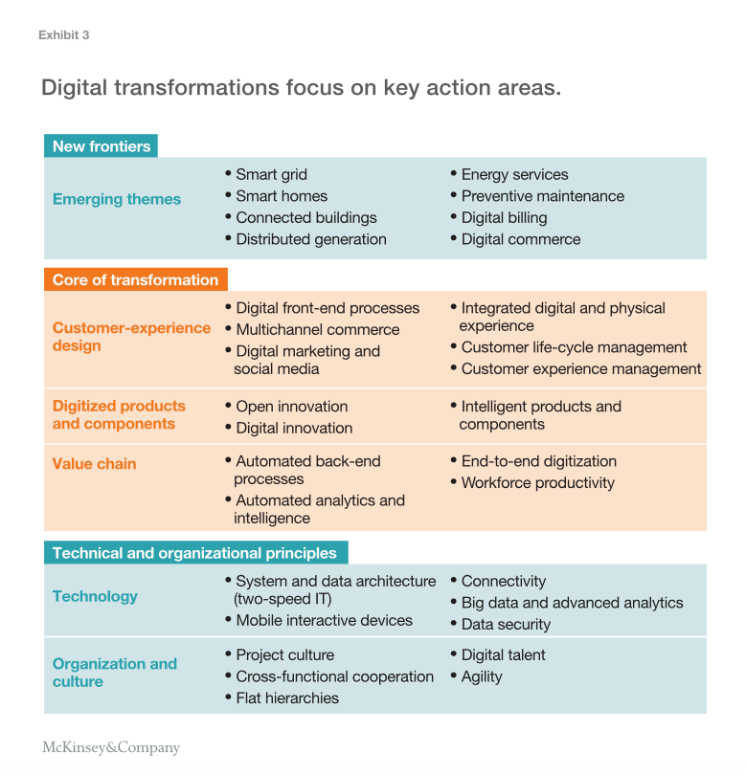

## Analytics

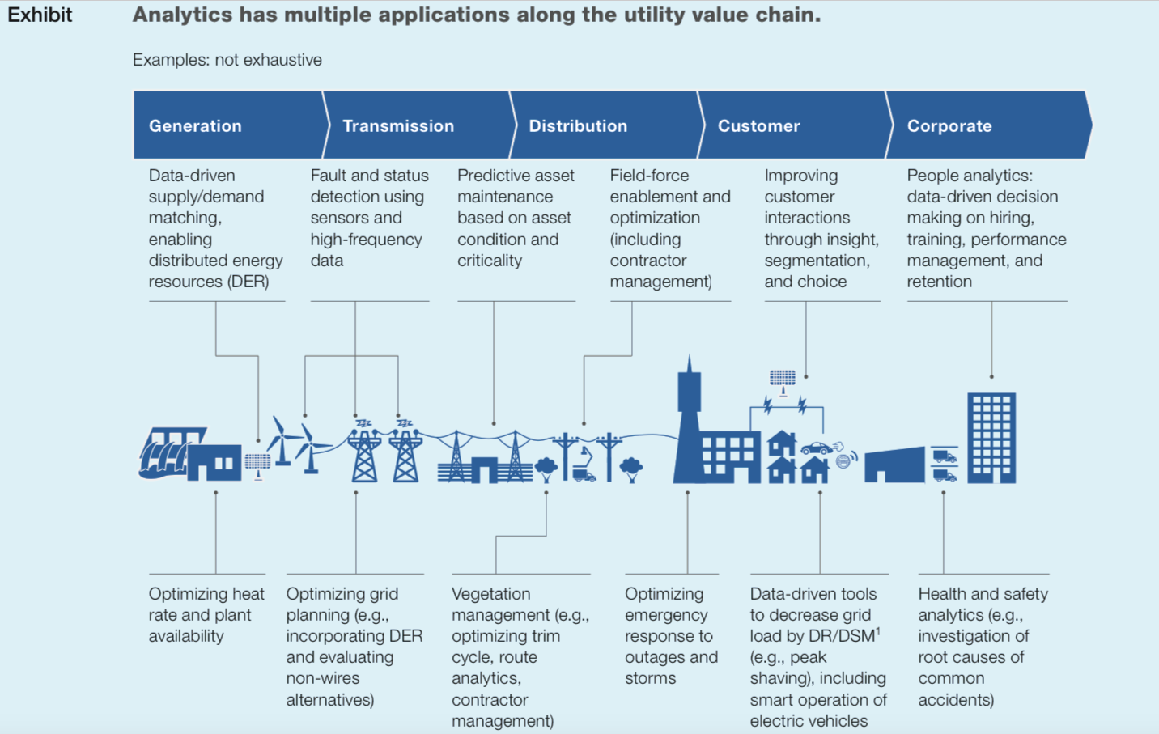Internet of Things (IoT)

**Resourceful planet Mega Trend #5 *Making Sense of the World in Mo3on***

Absolute **population growth**, **economic development** and more middle-class consumers will drive **increasing global demand for natural resources**.

hCp://www.ey.com/Publica1on/vwLUAssets/ey-megatrends-report-2015/$FILE/ey-megatrends-report-2015.pdf

# New micro/macro

# Business

|  |  |  |  |
| --- | --- | --- | --- |
|  |  |  |  |
| **Overlapping Trends** |  |  |  |
|  | digital threats |  |  |
|  | competition for face-to face customers switching online |  |  |
|  | IoT-product and management options |  |  |
|  |  |  |  |
| Regulation | AB 32 requires California to reduce its GHG emissions to 1990 levels by 2020 |  |  |
|  | California’s 33 percent Renewables Portfolio Standard (RPS by 2020) |  |  |
|  |  |  |  |
|  |  |  |  |
| Evolving Regulation |  |  |  |
|  | response to competitive pressures |  |  |
|  | regulatory model remains essentially unchanged | were written for an era that is largely past |  |
|  | evolving | not a resulted in a redefinition of the regu-latory paradigm in a fundamental way | |
|  |  |  |  |
|  |  |  |  |
|  |  |  |  |
|  |  |  |  |
| **Industry Trends** |  |  |  |
|  |  |  |  |
| Evolving Grid |  |  |  |
| nvestment in new tools— | sophisticated information technology and operating systems— |  |  |
| integrate a diverse  set of energy resources, large and small | traditional ther -mal generating plants, hydro plants, and large-scale wind and  solar farms to generally smaller, more local resources such as  combined heat and power plants, rooftop solar systems, com-munity solar gardens, micro-grids, electric vehicles, storage, demand response, and energy efficiency. | continue to maintain, upgrade, and modify their distribution  systems; |  |
|  |  | to invest in technology; |  |
|  |  | increasingly to collabo-rate with three key strategic groups: |  |
|  |  | 1.technology companies, | whose innovative products and services plug into the grid |
|  |  | 2. reg-ulators, | who define appropriate business models for the grid  platform and determine "just and reasonable rates" for custom- ers, while assuring that the utility remains a healthy and viable  business that can meet customers’ needs |
|  |  | 3. Customers | specific needs and desires |
|  |  |  |  |
| automatic high-speed decision-making | |  |  |
| resource opera -tions are efficient. |  |  |  |
|  |  |  |  |
|  |  |  |  |
| Gird of Things (PG&E Vision) |  |  |  |
| investment. |  | grid mod-ernization, which means more than replacing wires and pipes | |
|  |  | putting in sophisticated information technology  and operating technology, and data analytics capabilities that  allow us to optimize that technology |  |
|  | adding new voltage controls | allow the grid to han-dle power from multiple resources, |  |
|  | advanced sensors | visibility and flexibility in how we run the system |  |
|  | greater automation. | smart switches | avoid millions of minutes of interruptions for our customers and  moved us toward our goal of a self-healing grid |
| having the right policy approaches |  |  |  |
|  | smart about supporting and encouraging innovation |  |  |
|  |  |  |  |
| continue driving innovation. |  |  |  |
|  | focus on partnerships. |  |  |
|  | driven by non-traditional players. |  |  |
|  |  |  |  |
| ACTIVE & DYNAMIC GRID | harnesses the power of the Internet of Things  (IoT) |  | Philip Mezey President & CEO, Itron |
| evolve to be more dynamic and actively solve problems. |  |  |  |
| We lose $24 billion annually in electricity transmission  and distribution. |  |  |  |
| It costs the US $2 billion per year for natural gas that is  unaccounted for and never used. |  |  |  |
| We lose $13 billion in water every year. That’s an  expensive lea |  |  |  |
| IMPROVE POWER RELIABILITY AND RESILIENCE | smart  meters | automatically notify us of power  outages | Kenneth M. Mercado Senior Vice President, Electric Operations, CenterPoint Energy |
| ENABLE CUSTOMER SERVICES, APPLICATIONS, AND CHOIC |  |  |  |
|  | CenterPoint Energy’s smart grid, | two-way communi-cation and multi-channel meters |  |
|  | Smart-grid-enabled products and services | such as energy analy-sis tools,  time-of-use rates,  peak-time rebates, and  pre-paid service |  |
| BE SECURED FROM CYBER AND OTHER THREATS |  |  |  |
| Roadmap of the future grid |  |  | Robert Schimmenti Senior Vice President, Electric Operations, Consolidated Edison Company of New York |
|  | less centralized |  |  |
|  | more distributed grid |  |  |
|  | distributed energy resources (DER) and micro-grids will likely participate  as an integrated extension of the delivery grid |  |  |
|  | accommodate greater penetration of DERs | by inte- grating modern communications and data platforms for  smart monitoring and control, |  |
|  | solve interconnection  challenges | through advanced network systems design. |  |
|  | We will expand our ability to engage customers in manag-ing their usage | harnessing more data and analytics, and  develop incentive programs that will drive their responses |  |
|  | defer a $1.2 billion  substation build. | incentivize customers and  developers to implement DERs |  |
| ADVANCED PV INTERCONNECTIONS: | highly reliable networked distribution instead  of more typical radial or loop configurations | would recognize and respond to  faults, |  |
|  |  | but allow power flow to and from the solar customer. |  |
|  | integrated into our SCADA platform, | allowing con - trol room operators to communicate remotely with the network  protector nodes as well as the customer’s PV inverter. |  |
| The 21st century plug-n-play system | advent of the Internet and its network of informa-tion sharing, data management, and communications, | greater monitoring, control, and optimiza - tion, ultimately leading to a self-healing grid. |  |
|  | Information technology  sensors, microprocessors, software and the like ("smart devices")  are fast becoming integral parts of the electricity network. |  |  |
|  | rooftop solar, electric  vehicles, and smart thermostats |  |  |
| Grid Platform Optimization | Microsensors, low cost computer processing, and wireless com - munications, as well as data management/analytics | provide the  utility operator with a remarkable set of new tools to drive effi-ciency in the energy supply chain. |  |
|  | eating sensors, voltage and load  monitors, and smart meter data can | address predictive mainte-nance, grid resilience, and electricity theft matters. |  |
| DEPLOYMENT OF CONNECTED PRODUCTS  AND DATA ANALYTICS | utilize data in new ways. |  |  |
|  | smart devices today can meter their own energy use,  and many have machine learning and automatic controls built  in, so | we can know ahead of time when and how much energy  will be used. | will require utilities to break down historic  silos between operations technology (OT) engineers and infor-mation technology (IT) professionals |
|  | customer data should be as pri -vate as possible |  |  |
|  | mart devices and data collection/analytics will require enhanced cyber security  measures. |  |  |
|  |  |  |  |
|  |  |  |  |
| Delivering Customer-focused energy solutions |  |  | Mark S. Lantrip Chairman, President and Chief Executive Officer, Southern Company Services, Inc. |
| Grid devices and optimization | Increasing the number and capability of smart field devices  on the grid | provides opportunities for improved optimization |  |
|  | Smart Grid Investment Grant (SGIG), in partnership with the US  Department of Energy | faster recognition of outage locations |  |
|  |  | improved reliabil-ity from quicker service restoration, |  |
|  |  | reduced maintenance  costs and equipment failures |  |
|  |  | optimized grid operations, and |  |
|  |  | enhanced situational awareness and visualization of the system for faster and better decision-making. |  |
|  | Advanced Metering Infrastructure  (AMI), also known as "smart meters |  |  |
|  |  | beyond the cost savings and reduced vehicle emissions from remotely reading the meters |  |
|  |  | operational information the meters provide. | identify voltage issues on the grid, respond more quickly and efficiently to outages, and take both proactive and reactive corrective action. |
|  | identify the hardest-hit areas and  create staging sites and material distribution facilities to sup - port 10,000 restoration personnel from 20 states. | drew  on data from newly-installed smart meters, real-time systems,  and aerial imagery to quickly identify the hardest-hit areas |  |
| Energy Innovation  Center | dedicated to developing solutions custom - ers need today and will need tomorrow—through collaborative  partnerships. |  |  |
| Top Three myThs |  |  | Bradley Williams Vice President, Industry Strategy, Oracle Utilities |
|  | We don’t have the technology to support this  vision of the smart grid |  |  |
|  | Big Data will solve all of our problems |  |  |
|  | We can leverage existing operational solutions,  expanding them to enable the grid of the future |  |  |
|  |  |  |  |
| connecting the dots | ongoing dialogue and partnerships. |  | Evolving Grid 37 Thomas R. Kuhn President, Edison Electric Institute |
| Grid 2.0 | distributed energy resources (DER), renewable energy, and  energy storage. |  | Keit h Trent Executive Vice President, Grid Solutions & President, Midwest and Florida Regions, Duke Energy |
|  | + |  |  |
|  | advanced computing, data analytics and mod - els, sensors, and telecommunications continue to drive auto - mation, increasing grid efficiency and system optimization |  |  |
|  |  |  |  |
|  |  |  |  |
|  |  |  |  |
|  |  |  |  |
| **Customer** |  |  |  |
|  |  |  |  |
| Evolving Customer |  |  |  |
|  | best service and the lowest prices, |  |  |
|  | maxi-mum flexibility, |  |  |
|  | and maximum value |  |  |
|  | maximum choice, |  |  |
|  | high-quality and reliable service at an affordable price. |  |  |
| Ecosystem collaboration | utilities,  technology companies, and regulators can collaborate to help  them take advantage of new service offerings and unlock the  value in those services. |  |  |
|  |  |  |  |
| help custom-ers unlock value— | from clean energy and efficiency goals, to  improved reliability, resiliency, security, and power quality? |  |  |
|  |  |  |  |
|  | put a solar panel on the rooftop, |  |  |
|  | want a battery in their garage |  |  |
|  | want to charge their electric vehicle anywhere and anytime and |  |  |
|  | sell stored electric-ity back to the grid for demand response. |  |  |
|  | plug in new devices and access new ser-vices from other providers, |  |  |
|  | expect seamless communica-tion with the utility. |  |  |
|  | sell excess power from their rooftop to their neighbor at the push of a button, using their Smartmeter and Smartphone |  |  |
|  |  |  |  |
|  |  |  |  |
|  |  |  |  |
| customers | have more devices connected to the  grid than ever |  |  |
| Many commercial and industrial customers have  systems that | require "clean" power, without voltage spikes and  frequency deviations. |  |  |
|  |  |  |  |
|  | expect excellent service from electric utilities as well, eg. Amazon, FedEx, and Apple, | |  |
|  | expect utilities to provide reliable, affordable elec-tricity 24/7 |  |  |
|  |  |  |  |
| gap between utilities’  and customers’ perspectives on the electricity service |  |  |  |
|  |  | bury my power lines? |  |
|  |  | use this cool new app I got with my smart meter? |  |
|  |  | Why do I need a "smart meter"? |  |
|  |  | Why do you want to know about my power usage? |  |
|  |  | Are you sharing my information with the government? | |
|  |  | How will these reliability improvements help me? |  |
|  |  |  | Stephen Callahan Vice President, Global Strategies and Solutions, Energy and Utilities, IBM |
|  | Are we incentivized to invest in innovation? |  |  |
|  | figured out the IT challenges of Smart Grid? |  |  |
|  | have smart technology synched with smart regulation? |  |  |
|  | What is this "post-industrial" electricity industry? | more electric, more distributed, and more uncertain— both economically and physically. |  |
|  |  |  |  |
| One-Stop Shop for Customers |  |  | Ted Craver Chairman, President and CEO, Edison Internationa |
|  | f the power goes out even for a couple of  seconds | customers have to reboot all their digital devices. | Donwtime can be expensive |
|  | ndustry averages 99.99 percent availability—less  than an hour of downtime per year. |  |  |
|  | Business customers | two-thirds of Southern  California Edison’s load. |  |
|  |  | high power-quality needs. |  |
|  |  | back-up systems |  |
|  |  |  |  |
|  |  |  |  |
|  |  |  |  |
|  |  |  |  |
| **Digital Technologies** | Data collection and exchange are growing exponentially |  |  |
|  |  |  |  |
| three development waves |  |  | smart meters, samrt grid, |
|  |  |  |  |
| productivity and efficiency, / |  |  |  |
| *profitability by 20 to 30 percent* | 23.2% EBIT |  |  |
|  |  |  |  |
|  | Generation | Optimized plant maintencne |  |
|  |  | spare-parts management |  |
|  |  | Fuel management |  |
|  | Trading |  |  |
|  |  | improved decision-making |  |
|  |  | better overall energy balance | analytis and modeling |
|  |  |  |  |
|  | Distribution | Fewer losses |  |
|  |  | preventative maintenance | analytics |
|  |  | workforce productivity | analytics, optimization |
|  |  |  |  |
| the customer experience, | Retail | individual new products | analytics |
|  |  | better prices and customer segmentation | analytics |
|  |  | digital operations | platforms |
|  | (profitable analysis of customer behavior through the entire customer journey) | multi-channel platform | online, mobile, call center, and local sales |
|  |  | customer experience design | digitla front-end process |
|  |  |  | digital marketing and social media |
|  |  | integrated digital and physical expeirence |  |
|  |  | customer life cycle management |  |
|  |  | customer experience management |  |
|  |  |  |  |
|  |  |  |  |
|  | Group headquarters | Operations operations and management | optimization |
|  |  | digital productitivty tools for employees | Mobile enablement |
|  |  | automation of back-office processes |  |
|  |  | better workflow management |  |
|  | (productive by 15 percent) | route planning and management tools | GPS, traffic information |
|  |  |  |  |
| and new frontiers. |  | distributed generation |  |
|  |  | efficiencies in energy and facility maintenance |  |
|  |  | samart homes, connected buildings, smart cities | networked energy management |
|  |  | energy services |  |
|  |  | Digitized products and components | open/digital innovation |
|  |  | Intelligent products and components |  |
|  |  |  |  |
| Technical and organization principles | Technology | System and data architecture (TWO speed IT) |  |
|  |  | Mobile interactice devices |  |
|  |  | Connectivity |  |
|  |  | big data anad advanced analytics |  |
|  |  | data security |  |
|  | Organizational |  |  |
|  |  | project culture |  |
|  |  | cross-functional cooperation |  |
|  |  | flat hierachies |  |
|  |  | digital talent |  |
|  |  | agility |  |
|  |  |  |  |
| Transformation & technique |  |  |  |
|  | elevate the importance of design | simplicity, user-friendly |  |
|  | agile approach |  |  |
|  | start with the end user |  |  |
|  | stablish two-speed IT | existing IT architecture and processes |  |
|  | define targets and link budgets to progress |  |  |
|  |  |  |  |
|  |  |  |  |
|  |  |  |  |
|  |  |  |  |
|  |  |  |  |
|  |  |  |  |
| ||^ |  |  |  |
|  |  | distributed energy resources, individual sites to entire systems, | Digital management |
|  |  | bill notification and payment | mobile apps - |
|  |  | outage management | mobile apps - |
|  |  | maintenance and outages | predictive analytics |
|  |  | alignment of supply and demand | big data |
|  |  | improve network resiliency, safety, and efficiency | automated controls |
|  |  | custom customer interactions | segementation, personalization, customer journeys |
|  |  | distributed energy | platforms |
|  |  | marketplaces | platforms |
|  |  | back-office, decision making | automation |
|  |  | field workforce management | mobile apps - |
|  |  | energy balancing | situaltional awareness |
|  |  |  |  |
|  |  |  |  |
|  |  |  |  |
| http://www.mckinsey.com/industries/electric-power-and-natural-gas/our-insights/the-digital-utility-new-opportunities-and-challenges?cid=digistrat-eml-alt-mip-mck-oth-1605 | | | |
|  |  |  |  |
| Government regulations | encourage smarter measuring systems |  |  |
|  | greener standards for generation and consumption. |  |  |
|  | santa monica ordinance | minimum total wattage of 1.5 times the square footage of the dwelling (1.5 watts per square foot). | |
|  |  | 2.0 times the square footage of the building footprint (2.0 watts per square foot of building footprint) | |
|  |  |  |  |
|  |  |  |  |
| New energy sources | [National Renewable Energy Laboratory thinks we can get 40% of our electricity from 23-27% of our countries buildings](http://www.nrel.gov/news/press/2016/24662) | |  |
|  |  |  |  |
|  |  |  |  |
| Solar prices |  |  |  |
|  | between $3.27-3.54/sq ft in construction costs | The energy savings will more than offset mortgage pricing increases – lowering ownership costs from day one. | |
|  | [33-37% below current solar market prices](https://docs.google.com/spreadsheets/d/1r4kFrSdtdIAHSy7YbezC0pApAjgWoKtFOsaT92HOvAw/edit?usp=sharing) |  |  |
|  | 30% tax credits |  |  |
|  | @ < 60% (2014) |  |  |
|  | ??? purchased and installed for less than $1.90 per Watt after applying the 30% federal tax credit. | 7 cents per kWh in many parts of the country | vs solar leasing company ( $12 cents to $16 cents per kilowatt hour rate ? ) |
|  | stanalone solar tracking systems for the home - Dovolenk, designed by Architect/Owner David Komonosky, engineered by Q3 Engineering and built by Meeker Homes. Hardware – Dual Axis Trackers by Deger, BYD Solar Modules, BAE Batteries and Schneider Inverters. | | |
|  | Dubai received bid of $.0299/kWh for 800MW of solar power. | http://electrek.co/2016/05/15/solar-prices-set-to-fall-33-santa-monica-says-for-every-home-and-office-a-solar-power-plant/ | |
|  | AT&T’s IoT (Internet of Things) expertise combined with the SunPower Equinox home solar and monitoring system | |  |
|  |  |  |  |
| Microgrids | individual buildings, resorts, mine sites, remote villages, small islands and others. | total power demand from 100 kW to 20 MW. |  |
|  | CAT |  |  |
|  |  |  |  |
|  |  |  |  |
| mega energy |  |  |  |
|  |  |  |  |
|  |  |  |  |
| Storage | fast evolving energy storage market |  | uncertainty |
|  |  |  |  |
|  |  |  |  |
| Climate change | dangerous climate change |  |  |
|  |  |  |  |
|  |  |  |  |
| electric vehichle charging |  |  |  |
|  |  |  |  |
|  |  |  |  |
| Dsitributed generation | Distributed energy resources (DER) such as micro-generation, distributed generation, electric vehicles and energy storage devices are becoming more numerous due to the many initiatives to de-carbonize the power sector. | | |
|  |  |  |  |
|  |  |  |  |
| Virtual Power Plant (VPP) | Virtual Power Plant (VPP) is to aggregate many small generators into blocks that can be controlled by the system operator and then their energy output is traded [11] | | |
|  |  |  |  |
|  |  |  |  |
|  |  |  |  |
|  |  |  |  |
| **Issues** |  |  |  |
|  |  |  |  |
| aging infrastructure | transmission and distribution equipment that was installed then is now beyond its design life and in need of replacement | |  |
|  |  |  |  |
| rightof way issues | difficulties in obtaining rights-of-way and environmental permits |  |  |
|  |  |  |  |
|  |  |  |  |
| transmission lines | some of the existing power transmission and distribution lines are operating near their capacity and some renewable generation cannot be connected | | |
|  |  |  |  |
| over-voltages | over-voltages at times of light load, thus requiring the coordinated operation of the local generation, on-load tap changers and other equipment used to control voltage in distribution circuits. ` | | |
|  |  |  |  |
| retaining customers | struggling to retain customers and fend off new threats in distributed generation |  |  |
|  |  |  |  |
|  |  |  |  |
|  |  |  |  |
| **Digital Transformation** |  |  |  |
|  |  | |  |
|  |  |
|  |  |
|  |  |
|  |  |
|  |  |
|  |  |
|  |  |
|  |  |
|  |  |
|  |  |
|  |  |
|  |  |
|  |  |
|  |  |
|  |  |
|  |  |
|  |  |
|  |  |
|  |  |
|  |  |
|  |  |
|  |  |
|  |  |
|  |  |
|  |  |
|  |  |
|  |  |
|  |  |
|  |  | |  |
|  |  |
|  |  |
|  |  |
|  |  |
|  |  |
|  |  |
|  |  |
|  |  |
|  |  |
|  |  |
|  |  |
|  |  |
|  |  |
|  |  |
|  |  |
|  |  |
|  |  |
|  |  |
|  |  |
|  |  |
|  |  |
|  |  |
|  |  |
|  |  |
|  |  |
|  |  |
|  |  |
|  |  |
|  |  |
|  |  |
|  |  |
|  |  |
|  |  |
|  |  |
|  |  |
|  |  |
|  |  |
|  |  |
|  |  |
|  |  |
|  |  |
|  |  |
|  |  |
|  |  |
|  |  |
|  |  |
|  |  |
|  |  |
|  |  |
|  |  |
|  |  |
|  |  |
|  |  |
|  |  |
|  |  |
|  |  |
|  |  |  |  |
|  |  |  |  |
| https://upload.wikimedia.org/wikipedia/commons/thumb/2/29/Swansons-law.png/800px-Swansons-law.png   |  | | --- | |  | |  |  |  |
|  |  |  |  |
|  |  |  |  |
|  |  |  |  |
|  |  |  |  |
|  |  |  |  |
|  |  |  |  |
|  |  |  |  |
|  |  |  |  |
|  |  |  |  |
|  |  |  |  |
|  |  |  |  |
|  |  |  |  |
|  |  |  |  |
|  |  |  |  |
|  |  |  |  |
|  |  |  |  |
|  |  |  |  |
|  |  |  |  |
|  |  |  |  |
|  |  |  |  |
|  |  |  |  |
|  |  |  |  |
|  |  |  |  |
|  |  |  |  |
|  |  | http://s7d2.scene7.com/is/image/Caterpillar/C10873646?$cc-s$ |  |
|  |  |  |  |
|  |  |  |  |
|  |  |  |  |
|  |  |  |  |
| |  | | --- | |  | |  |  |  |
|  |  |  |  |
|  |  |  |  |
|  |  | Figure 2: Life-cycle cost trends, diesel vs. renewables |  |
|  |  |  |  |
|  |  | Sources: International Energy Agency, Lawrence Berkeley National Laboratories, National Renewable Energy Laboratory, | |
|  |  |  |  |
|  |  | U.S. Energy Information Administration, Clean Edge, Caterpillar. | |
|  |  |  |  |
|  |  |  |  |
|  |  |  |  |
|  |  |  |  |
|  |  |  |  |
|  |  |  |  |
|  |  |  |  |
|  |  |  |  |
|  |  |  |  |
|  |  |  |  |
|  |  |  |  |
|  |  |  |  |
|  |  |  |  |
|  |  |  |  |
|  |  |  |  |
|  |  |  |  |
|  |  |  |  |
|  |  |  |  |
|  |  |  |  |
| **Regulation** |  |  |  |

# **Macro Trends**

|  |
| --- |
| **Trend/Issue/Signal** |
| ECRI weekly |
| GDP Report |
| Yeild Curve |
| Consumer confidence |
| Retail Sales |
| New Home Sales |
| ISM Manufacturing Index |
| Trade Balance |
| Federal Budget Balance |
| CPI |
| PPI |
| US pension gap |

# Business operations

<https://www.bcg.com/en-us/publications/2017/people-organization-strategy-twelve-forces-radically-change-organizations-work.aspx>

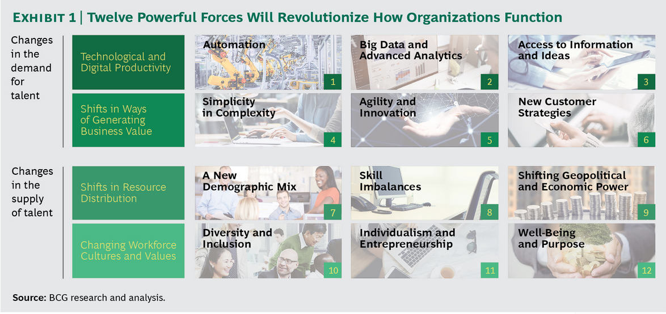

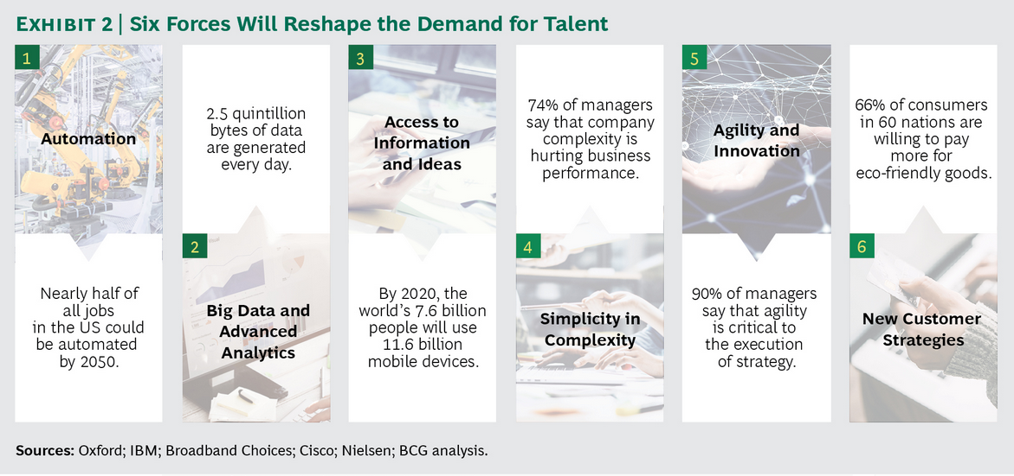

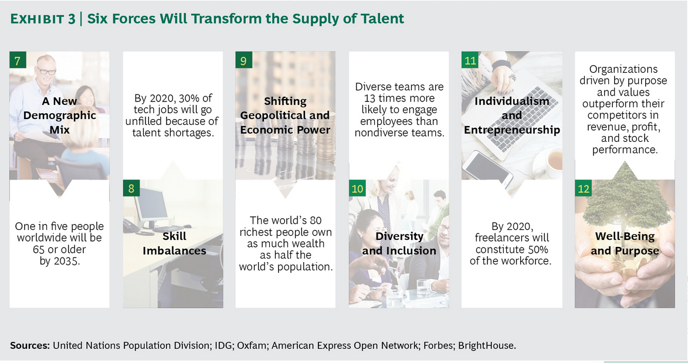

**Technological and Digital Productivity**

**Automation:** Industry 4.0; artificial intelligence, machine learning, and wearables; digital channels; augmented reality; and robotics

**Big Data and Advanced Analytics:** Predictive technology, integrated tools to optmize performance, social media insights, behavioral sensors, and big data

**Access to Information and Ideas:** Cloud-based technology and the “Internet of everything,” open-source software and processes, open innovation and peer-to-peer technology, decreasing degrees of separation, and new capital and infrastructure platforms

**Shifts in Ways of Generating Business Value**

**Simplicity in Complexity:** The value of simplicity, lean methodologies, the evolution from silos to more holistic organizations, specialization, and organizational complicatedness

**Agility and Innovation:** An accelerating pace of change, increasing uncertainty and black-swan events, exponential organizations, agile development, and digital stakes and subsidiaries

**New Customer Strategies:** Personalization and premium products and services, the sharing economy, data security, ethics, and the environment

**Shifts in Resource Distribution**

**A New Demographic Mix:** The “demographic dividend,” talent scarcity, aging populations, multiple generations in the workforce, and talent imbalances

**Skill Imbalances:** New skills, waning skill life, formal curricula and development, digital late-comers, and skills education and reach

**Shifting Geopolitical and Economic Power:** Disparity in wages and economic growth rates, multiple centers of power, urbanization and resource depletion, migration, and the rise of the middle class in developing countries

**Changing Workforce Cultures and Values**

**Diversity and Inclusion:** Multiculturalism, racial and ethnic diversity, gender equality, value pluralism, and equitable economic development

**Individualism and Entrepreneurship:** Freelance work versus employee loyalty, risk taking and entrepreneurism, multidisciplinary pursuits, talent renting and freelancing, and individualized aspirations

**Well-Being and Purpose:** Desire for personal, social, and communal impact; reflection and purpose; self-expression; appreciation and respect; and physical and mental health and balance

# Customer Trends

Extreme weather -

Wants-

* Simple

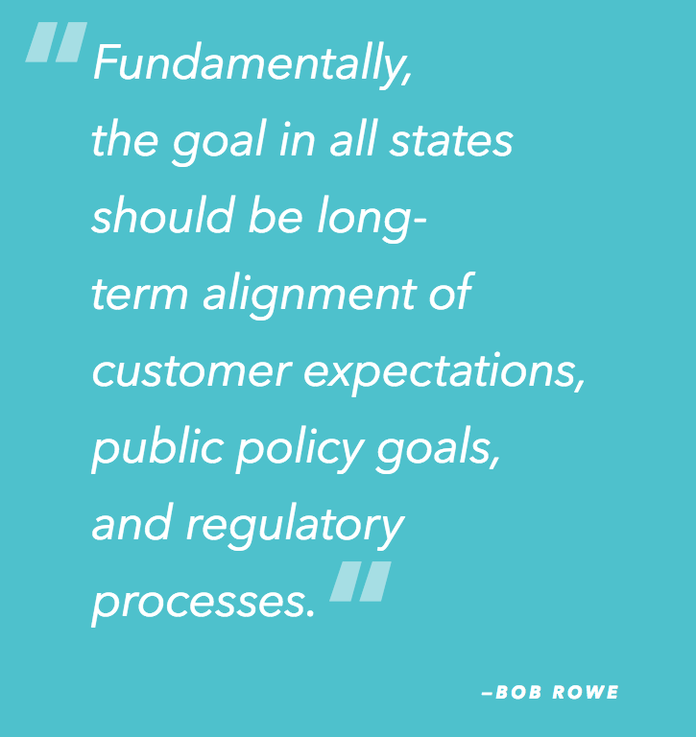

President and CEO, NorthWestern Energy

<http://www.edisonfoundation.net/iei/publications/Documents/Key_Trends_Driving_Change_Volume_III_FINAL.pdf>

# Utility Trends

# Disrupting Utilities-UK

Is it anyone’s game?

A potential revolution for the utilities industry is being led by advancements in smart home technology, real time data becoming available and evolving customer expectations. In a sector that is becoming increasingly digital, distributed and personalised, the door is wide open for truly innovative companies.

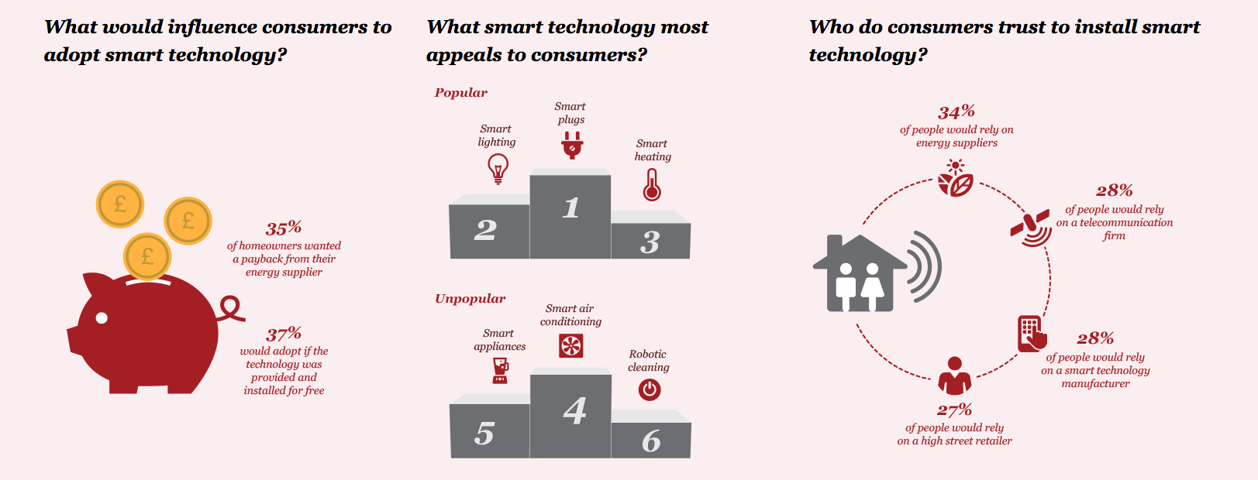

<https://www.pwc.co.uk/industries/power-utilities/insights/disrupting-utilities/consumer-survey.html>

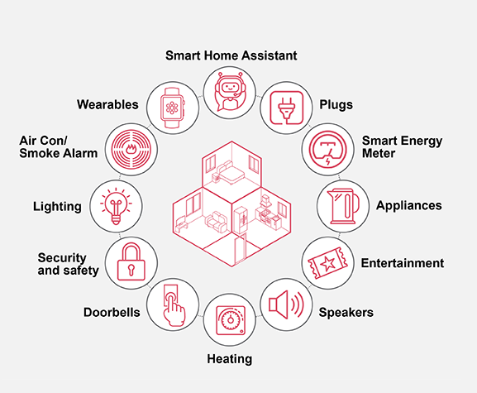

We surveyed over 500 UK businesses to understand their investment decisions in smart technology and the message was clear: utilities currently hold the power in the Smart Business Revolution and can take advantage of new revenue opportunities.

#### Utilities have the trust:

* 55% of businesses trust energy suppliers to install smart energy technology.

#### It’s a tight race:

* Engineering, technology and telecommunications suppliers are nipping at the heels of energy companies.

#### Market opportunity:

* Over a third of industrial firms and one in five commercial organisations are planning to invest over **£1m** on smart energy technology in the next five years.

With many companies looking to invest in smart energy and businesses becoming more confident across the technologies, the door is wide open for truly innovative companies.

However, there are some hurdles as well as opportunities along the way. To help you understand them, and your customers, we also asked companies their thoughts on:

* Demand side management
* Intended investment for individual smart energy technologies
* Which business needs motivate technology investment
* Security of supply
* Which technologies are addressing business needs and being adopted
* Energy strategy

[Please get in touch with us](https://www.pwc.co.uk/industries/power-utilities/insights/disrupting-utilities/the-smart-energy-business-revolution.html#contact) if you would like to find out more and to see all of the survey results.

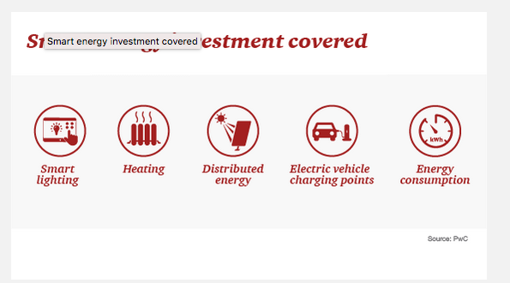

I**ndustrials** are in manufacturing, engineering, construction and production, and employ more than 250 employees or turn over more than £50M (or both). They are already **heavy adopters** of smart energy technology, and are also planning **heavy investment** with one-third intending to spend more than £1m on smart energy technology in the coming year.

**Commercials** employ more than 250 employees, or turn over more than £50M (or both). They operate in sectors such as Consumer goods, Hospitality & Leisure, Retail, Asset Management or Banking & Capital Markets. Despite being slower to adopt smart energy technology than industrials, they will be **future adopters**, with 23% intending to spend more than £1m on smart energy technology in the coming years.

**SMEs** are businesses employing fewer than 250 employees and have a turnover below £50 million - they are Britain’s independent corner stores, hairdressers, car repair workshops and fast food retailers. They are less likely than other sectors to be heavy users or future adopters of smart energy technology, but will be an **emerging opportunity** as technology improves and costs continue to fall.

**Public Sector & Institutional** organisations operate in the areas of Central Government, Healthcare, Charities/Third sector organisations or Housing Associations. They are most interested in technology that will help them better **monitor and manage energy consumption**.

## Decentralization – DERs

<https://www.accenture.com/t20170406T202722Z__w__/us-en/_acnmedia/PDF-48/Accenture_Future-Demand-Response-POV.pdf>

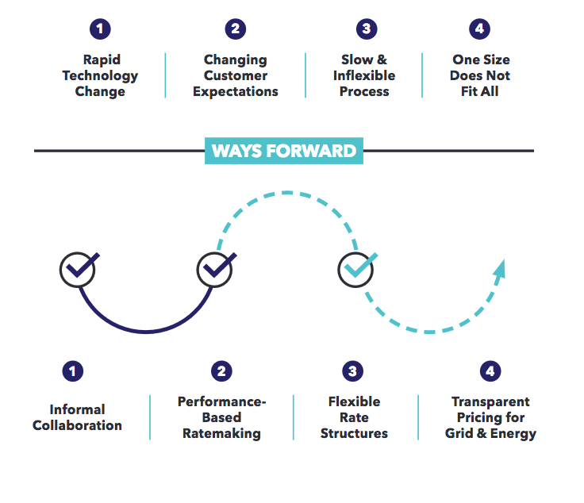

Rates

Today, many pricing structures are antiquated and no longer match cost with causation. [1] Vice President, Policy and Federal Affairs, Xcel Energy

Solar - universal solar is less than half that of private solar/Renewable*Connect

SM programs

Needs

more, customers also are asking that electric companies pro-vide a broad array of energy consulting

and management services

load growth

-Declining load growth (due in part to the success of our energy efficiency programs), coupled with rising fixed costs;

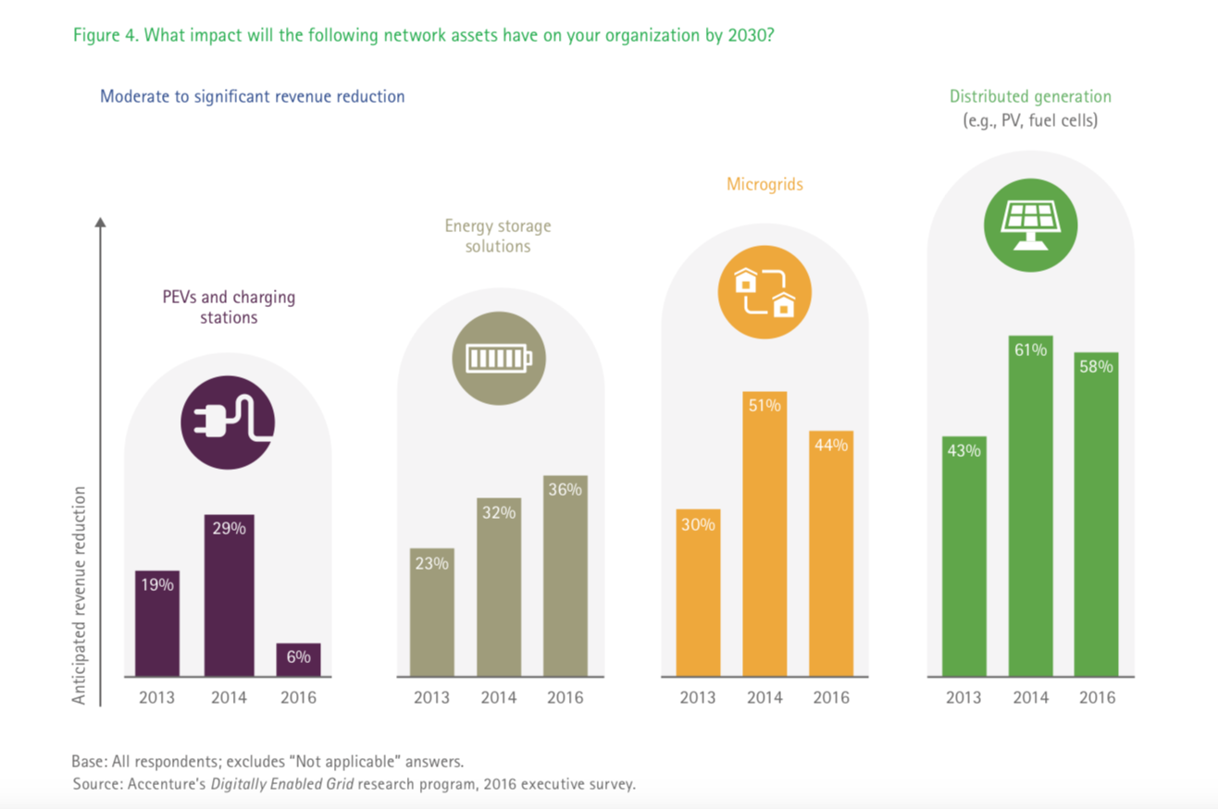

# Customer Segments – needs in the future.

|  |  |  |  |  |  |  |  |
| --- | --- | --- | --- | --- | --- | --- | --- |
|  |  |  |  |  |  |  |  |
| For profit (business) | (residential) For convenience/ satisfaction/  /needs | Transportation , Electrification of fleets, such as  city buses, school buses, and  the delivery vehicles used by  the U.S. Postal Service, United  Parcel Service, and FedEx, could  accelerate the EV market | Developer / redeveloper | a virtual power plant  (VPP)  aggregator |  |  |  |
| Usage pattern – time of day |  |  |  |  |  |  |  |
| Consumption amount /annual |  |  |  |  |  |  |  |
| Dominate usage | Thermal (A/C, refridge), EV, lights, devices |  |  |  |  |  |  |
| Actively control usage (pv, ee, dr, evelope, building mgmt) | Some control |  | Special tariff/price | How used | efficiency |  | No control |
| Sustainability | Pv no gain |  |  |  |  |  |  |
|  |  |  |  |  |  |  |  |
| Comm prefer | Internet/phone |  |  |  |  |  |  |
| Climate zone |  |  |  |  |  |  |  |
|  |  |  |  |  |  |  |  |
| Urban, rural |  |  |  |  |  |  |  |
| CEC sector |  |  |  |  |  |  |  |
| NAICS for office |  |  |  |  |  |  |  |
| $/kWhr /buckets (cluster to get size) |  |  |  |  |  |  |  |
| Preferences | Rank, sustainability |  |  |  |  |  |  |
| Satisfied / not satisfied |  |  |  |  |  |  |  |
| Needs/  1. Energy use problems |  | Studies show that 58 percent of  customers would like their electric com  -  pany to offer home energy manage  -  ment solutions, and 61 percent prefer  that electric companies provide home  monitoring and control solutions. his  preference is 1.5 times greater than  customers’ preference for retailers, and  more than double that for cable and  communications companies.  3  home energy management, | charging infrastructure,  smart rates, customer educa  -  tion, and customer access  , lack of standard EV charging  protocols[2] |  |  |  |  |
| Grid needs |  |  |  |  |  |  |  |
| Best @ executing: Value/cost – product model |  |  |  |  |  |  |  |
| Target Services /products |  | identify specific actions cus  -  tomers can take to save energy and  accurately estimate dollar savings that  would result from those actions.  -- Distributed  Low Voltage Regulators (DLVRs)—a new  set of flexible distribution grid build  -  ing blocks—use power electronics with  intelligent software controls to simplify  integration of renewables, increase  energy efficiency, and support new  load types  at the distribution trans  -  former.  Gridco Systems has pioneered develop  -  ment of DLVR |  |  |  |  |  |

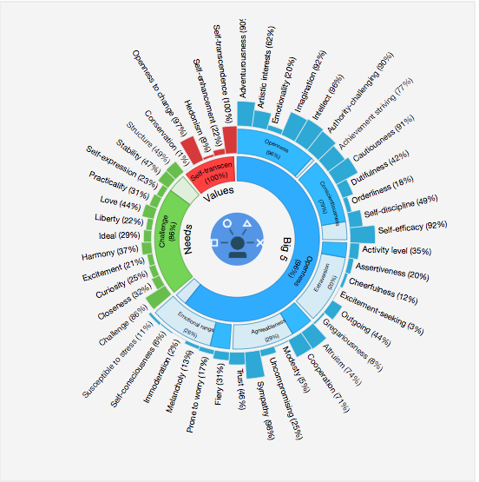

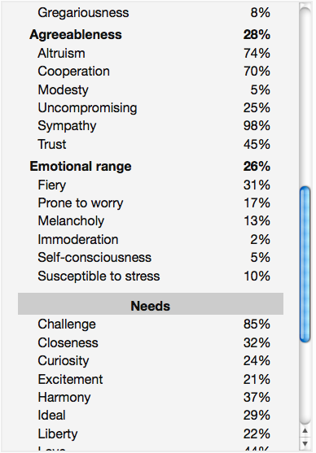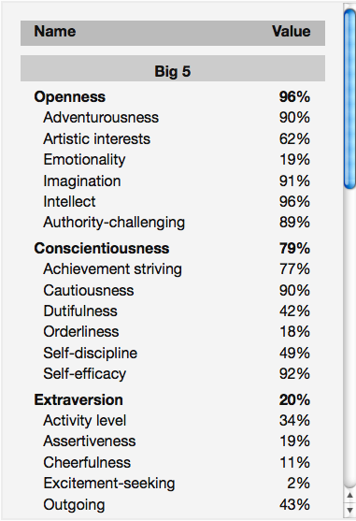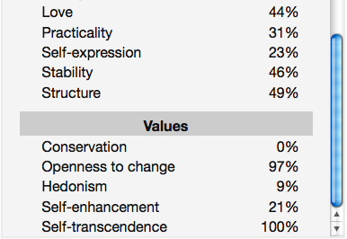

https://watson-pi-demo.mybluemix.net/

# Quantify what matters to your customers.

CenterPoint -79

Exelon – lowest

• Research shows that 55% of consumers are willing to pay more for a guaranteed good experience. Kolsky points out the word ‘guaranteed’, noting customers are no longer satisfied with just being promised a good experience.

• 86% of consumers are willing to pay more for an upgraded experience. Air travel and hospitality are examples where upselling better experiences can generate incremental revenue and bolster customer loyalty.

• 84% of consumers are frustrated when the agent does not have information.

• Customer frustration leads to the following: 13% tell 15 or more people if they’re unhappy. Conversely, 72% of consumers will share a positive experience with 6 or more people.

• 67% of consumers site bad experiences as reason for churn.

Kolsky researched and surveyed business leaders to find other critically important trends regarding customer experience including:

• 50% of customer experience natural occurring churn every 5 years.

• Only 1 out of 26 unhappy customers complain. The rest churn. A lesson here is that companies should not view absence of feedback as a sign of satisfaction. The true enemy is indifference.

• 91% of unhappy customers who are non-complainers simply leave.

• It is 6-7X more expensive for companies to attract new customers than to keep existing customers.

• 65% of companies are able to successfully upsell or cross-sell to existing customers.

• Only 12% of companies are able to successfully upsell or cross-sell to new customers.

• 75% of brands do not know what engagement means - but are measuring “it”

**Figure 1: Engagement as an outcome, not a goal**

Research on customer retention further validates the importance of customer experience. Kolsky found that:

1. 66% of consumers who switched brands did so because of poor service
2. 85% of customer churn due to poor service was preventable.
3. 11% of customer churn good be prevented by simple company outreach.
4. 67% of customer churn is preventable if the customer issue was resolved at the first engagement.

Kolsky strongly advocates that companies must shift away from company-centric behavior (measuring results, benefits and value based on internal benchmarks and standards) to a customer-centric model where co-creation of value and an outside-in behavior is adopted to define mutual benefits to both customers and company.

[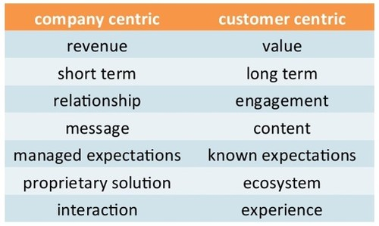](http://images.huffingtonpost.com/2015-10-14-1444846180-8063082-values.jpg)  
  
**Figure 2: Company-centric versus Customer-centric core values and guiding principles**

Kolsky points to online communities as an example of how customers are more empowered than ever before to share both positive and negative sentiments regarding their customer experience.

[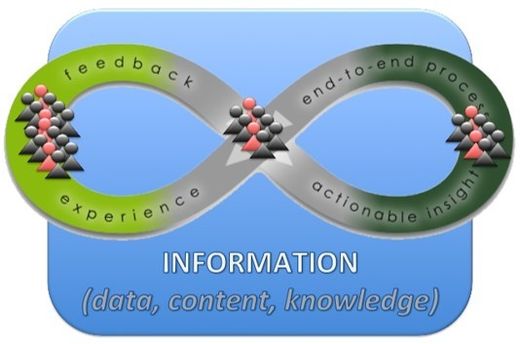](http://images.huffingtonpost.com/2015-10-14-1444846246-6387193-loop.jpg)  
  
**Figure 3: the birth of the community-powered continuum**

The [latest research](http://www.slideshare.net/ekolsky/cx-for-executives) by Kolsky found that **84% of organizations are now embracing the customer experience model.** Kolsky likens a company-centric experience design to a sledgehammer and a customer-centric experience design to a magnet - the power of pull is greater than the power of push.

Companies that deliver a good customer experience value customer feedback. Kolsky found that:

1. 70% of companies that deliver best in class customer experience use customer feedback - versus industry average of 50%, and 29% for laggards.
2. Customers are thirsty for more information and knowledge.
3. 56% of customer just want the right answer, but 64% of customers do not trust the information.
4. 44% of customers confirm that they have received the wrong answer.

Kolsky’s advice to companies is to focus on their job. The company’s job is less about knowing what the customer wants, and more about building the infrastructure to enable customers to freely choose, personalize and optimize their experience at every single interaction based on their needs. Companies must utilize the right technologies to build a self-learning infrastructure, designed for continuous improvement based on measured customer feedback. Ultimately, convenience wins. The infrastructure must be adaptive, flexible, scalable and intelligent.

Kolsky’s research and survey results regarding social, mobile, communities, journey mapping, engagement and knowledge management customer service should also be an eye-opener for business executives.

**Social customer survey results:**

1. 55% of customer requests for service on social media are not acknowledged.
2. 84% of social media service interactions are escalated to other channels.
3. 13% of companies claiming that 25% of service requests start socially.
4. 72% of Facebook interactions are never completed, in any channel.
5. 67% of escalated social interactional go back to channel of origin.

As a former social CMO and chief customer officer, responsible for managing global customer service centers of excellence, and someone who has had moderate success with social media, I would suggest that most companies are not investing enough to train and motivate their employees on effective use of social media. Companies that use social media as a megaphone, versus a telephone (bi-directional engagement) will not succeed. In my opinion, in today’s digital and on-demand economy, not responding to customers on social media is as damaging as not responding to a phone or email request. In 2014, for the first time ever, the number #1 use of the web was social networking. Over time, customers will choose social networking and private video streams as their preferred contact channel - most likely as an integrated community services with e-commerce - and companies must be prepared to deliver a consistent user experience across a variety of channels.

**Community survey results:**

1. 36% of customer service organizations deployed communities in the past 12 months
2. 84% of savings in cost per transaction fully completed in communities
3. Number of communities / online communities in 2008: 12 / 4
4. Number of communities / online communities in 2015: 46 / 24
5. 67% of service interactions are easily replaced with community interactions

The community survey results are important. In my experience, the company can be the spark, but for sustained momentum, the flames, heat and energy must come from the community. Community benefits extend far beyond customer service. Community driven businesses can see sales and marketing benefits. Integrated e-commerce and community platforms can produce significant incremental revenue streams. Forward looking and innovative companies leverage the community to enhance and scale their product roadmaps and service offerings. Communities will scale your brand as long as companies are interested and deliver value to the community.

**Omni-channel survey results:**

1. < 1% of companies deploying (deployed) omni-channel
2. 97% of companies that say are investing in omni-channel
3. 23% of companies doing multi-channel well
4. 2% of companies doing cross channel tracking of data
5. 67% of customers don’t care what channel is used

**Mobile survey results:**

1. 59% of customers adopting mobile technologies worldwide
2. 3% of global customers that express a preference for mobile
3. 15% of companies reported success when not taking a mobile first approach
4. < 1% of companies reported success with a mobile first strategy
5. 29% global companies prefer mobile devices to computers

I believe if you are company that views productivity as a function of location, then you are dying breed. Mobile is no longer about technology, but rather a lifestyle. [90% of time spent on mobile](http://www.businessinsider.com/time-spent-mobile-browsing-vs-apps-2015-9) smart device is behind apps (10% on a web browser) and that time equates to more than 200 [mobile moments](https://solutions.forrester.com/mobile/landing-61Q6-3212NK.html) per day for US adults, per [Forrester](https://www.forrester.com/home/), adding up to [30 billion ‘mobile moments’ occurrences](https://solutions.forrester.com/mobile) per day in the U.S.. These mobile moments drive the wearable revolution - glasses and watches. To deliver a solid customer experience, companies need to adopt design thinking and deliver simple, not simplistic, and insightful solutions. Mobile design requires solid UI/UX expertise that is a part of the initial product design requirements. In my opinion, mobile-first is a must because mobile as an afterthought is the fastest way for companies to become irrelevant.

**Customer journey mapping survey results:**

1. 34% of companies have undertaken CJM
2. 2% of companies that have reported success with CJM
3. 13% of customers who say CJM worked for them
4. 72% of customers who said CJM missed their needs
5. 67% of customers who expressed no interest in CJM being used

In my opinion, customer journey mapping is a sophisticated process that requires the right talent, lean and automated processes, a content generation factory and a publishers mindset and skill, a culture of discipline, investment in marketing/sales/services CRM capabilities and data-driven methodologies. Companies that invest in market, industry and buyer segmentation analysis, including buyer persona and buyer process map (BPM) analysis can have success with journey mapping. CJM is promising for companies that have mature digital transformation strategy and operational excellence. Without CJM, precision and personalized sales, marketing and services capabilities cannot be achieved.

**Engagement survey results:**

1. 58% of companies doing customer engagement (all definitions)
2. < 1% of companies can measure customer engagement
3. 91% of non-engaged customers leave with dissatisfaction

In my experience, measuring customer engagement at scale requires investment in marketing automation capabilities that is fully integrated with the sales, service, marketing and community CRM platforms. In B2B, based on my experience, there are a dozen or more meaningful touchpoints during the buyer’s journey including field events, proof of concept trials, consumption of content (white-papers, video seminars, product data sheets, etc.), social networking engagements, community activity, face-to-face meetings, customer service contacts, and more. Companies with fully integrated solutions can map each customer touch-point to sales opportunities, measuring the potential influence of sales, marketing, and customer service towards the overall customer experience. Companies who care about the customer experience proactively solicit for feedback, review the feedback, and action accordingly in a timely and responsive manner.

**Knowledge management survey results:**

1. 78% of customers who expect to get an answer from self-service
2. 84% of customers are frustrated when the service agent does not have information

The 50 customer statistics above cover a number of important areas and technologies. We can write a post for every single section noted above (Kolsky has volumes of supportive data to help us with that). That said, we also need to think about emerging technologies like the Internet of Things (IoT) and the profound impact that it will have on the customer experience.

Kolsky also shares his view of improving the customer experience with the Internet of Things or Internet of Customers. The Internet of Things (IoT) will change [business models](https://hbr.org/2014/07/how-the-internet-of-things-changes-business-models) and service delivery requirements. The Internet of Customers is something that all executives must understand and include as part of their digital transformation blueprint. [Insert link here] Kolsky believes that the IoT will transform customer services and significantly change customer expectations. The machines will integrate into the lives and businesses of consumers, producing data that can be acted upon in real-time, with specific actions that are personalized to deliver meaningful value. In a hyper-connected economy, the expectation will be for companies to deliver proactive services based on real-time analysis of customer (and device or ‘thing’) generated data.

In summary, business executives must be fully aware, understand and be committed to continuously improving the customer experience. The best gift that you can give to your competitors is poor customer experience. To learn more about the science and art of delivering superior customer experience, I encourage you to read Kolsky’s blogs and follow him on Twitter at [@ekolsky](https://twitter.com/ekolsky).

<https://twitter.com/ValaAfshar>

Chief Digital Evangelist [~~@~~**Salesforce**](https://twitter.com/Salesforce) | Blog: [~~@~~**HuffPost**](https://twitter.com/HuffPost) [~~@~~**ZDNet**](https://twitter.com/ZDNet) | Show: [~~@~~**DisrupTVShow**](https://twitter.com/DisrupTVShow) | Book: [http://bit.ly/tposbe](https://t.co/oSpLljigAi)

# Company goals – alternate to road maps

The learning organisation

Companies need to become learning organisations if they are to make full use of the potential of exponential technologies in achieving the digital transformation to industry 4.0.

<https://www2.deloitte.com/content/dam/Deloitte/ch/Documents/manufacturing/ch-en-manufacturing-industry-4-0-24102014.pdf>

<https://www.westmonroepartners.com>

<https://www.westmonroepartners.com/Insights/Solution-Briefs/EU-Performance-Management>

## roadmap vs gist

better alternative

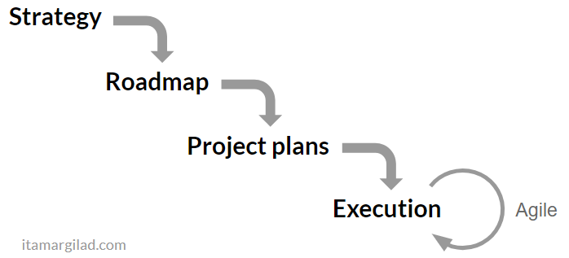

* massive undertaking
* ROI is very low
* plans quickly go out of sync
* outdated the day I published them
* no room for agility — changes at the top cause huge ripple effects of replanning and project cancellations at the bottom

GIST

based on the principles of Lean Startup and Agile Development

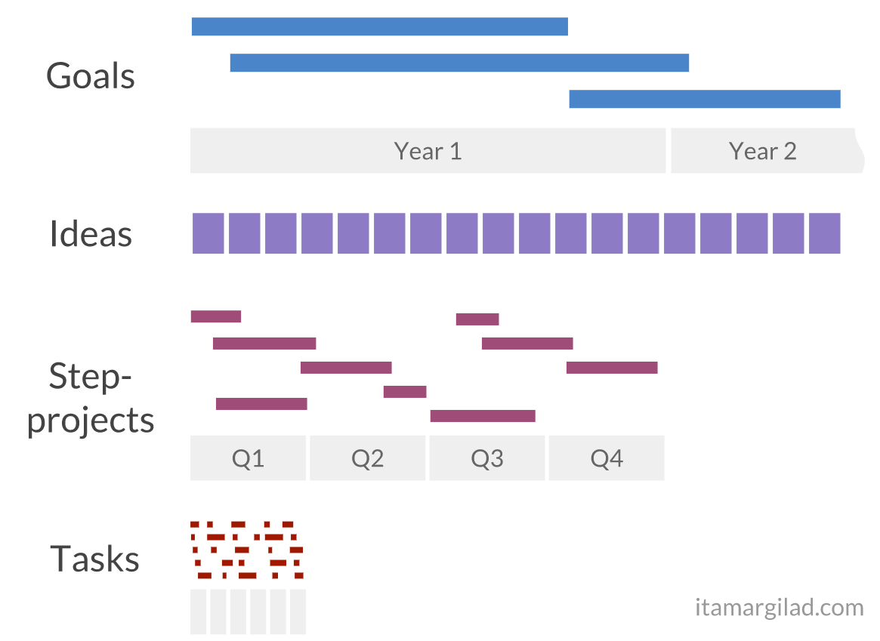

### Goals

“If you tell people where to go, but not how to get there, you’ll be amazed at the results” — George S. Patton.

Most strategy plans commit a cardinal sin —

* they specify solutions (use technology X, partner with company Y, launch country Z)
* rather than goals.

Goals embody this principle — they describe the company strategy in terms of desired outcomes:

Google - goals in the form of [Objectives and Key Results](https://www.google.com/url?q=https://rework.withgoogle.com/guides/set-goals-with-okrs/steps/introduction/&sa=D&ust=1517339886534000&usg=AFQjCNFcMmXatcq6fBQAthzzdN3KV94PFg) (OKRs). Some believe that OKRs are one of the reasons why Google is so successful.

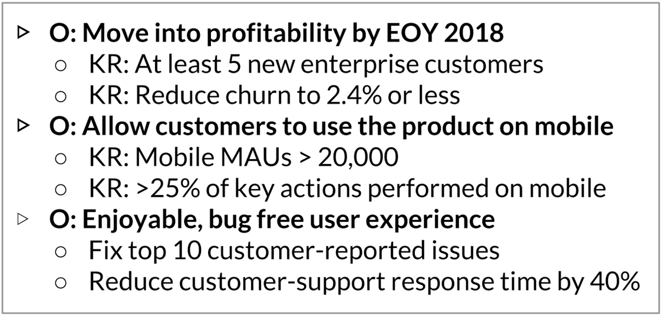

Ideas describe hypothetical ways to achieve the goals

Collect all ideas in an Idea Bank

Prioritize using [evidence](https://hackernoon.com/finding-winning-ideas-using-the-confidence-tool-d8f2d8cc2c15)

Step projects - “Think Big but Start Small” — [Google’s 8 pillars of innovation](https://www.google.com/url?q=https://www.thinkwithgoogle.com/marketing-resources/8-pillars-of-innovation/&sa=D&ust=1517339886538000&usg=AFQjCNERBMjZ6LpmhW8i1So2G3kMY6m6vA)

It’s tempting to pick a promising idea, turn it into a 9–18 month project and start executing.

PROVE IDEA FIRST

mockup → prototype → MVP → dogfood → beta → Launch

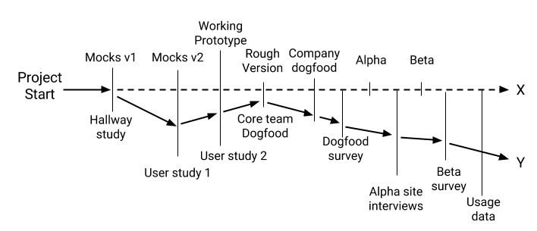

Tasks

each step-project is broken down to bite-size activities which we call here Tasks

Process

* **Goals** are typically set for an horizon of one or more years — this is where we want to encourage long-term thinking. They are defined at the beginning of the year and evaluated and adjusted every quarter — we don’t want to pursue stale goals.
* **Ideas** are constantly collected and prioritized. We never stop looking for new ideas.
* **Step-projects** are defined at the beginning of the quarter. The team picks the goals and ideas it wishes to pursue this quarter, and defines step-projects accordingly. The quarterly step-project list (typically stored in a spreadsheet or database tool) is evaluated and reprioritized every 1–2 weeks, in sync with task iterations planing.
* **Tasks** are planned in 1–2 week iterations in per the teams’ preferred dev method, for example Scrum sprint planning, and adjusted daily.
* 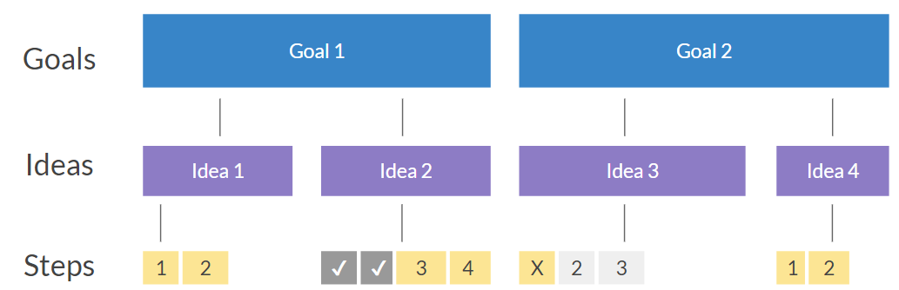

<https://hackernoon.com/why-i-stopped-using-product-roadmaps-and-switched-to-gist-planning-3b7f54e271d1>

Key principles:

* No split of ideation, planning and execution — they all happen concurrently all the time
* Goals rather than solutions or vague strategy statements.
* Idea banks rather than product backlogs.
* Short sub-quarter step-projects rather than long multi-quarter/multi-year projects.
* No betting on just a few big ideas that take forever to implement — we test many ideas quickly and pursue the ones that work.
* Iterations — we revisit every part of the plan regularly and systematically and stay agile at all levels.

# Goals -basic

|  |
| --- |
| What is the strategic intent? |
| performane levers used to achieve this intent |
| Target foothold customer |
| version 1.0 of the offereing will look like |
| existing and potential customers |
| we will minimize and avoid competition by |
| our revenue model will be |
| the reason we believe it could be big (>$1B) by year 5 is |
| We will create it by |
| we will deliver it by |
| We will market it by |

KPI’s:

* “The term key performance indicator ( KPI) is often used to denote a ***strategically aligned” metric***.
* KPI=strategic objective
* KPIs measured against **targets** ***(range - encoded)***, per unit timeframe. Targets are measured against a benchmark.
* Your **unique set of KPIs =important + Innovative**
* **Comprehensive list of KPIs (aspects of the organization that are most critical)**
* <http://www.ap-institute.com/> **(list of KPIS)**
* **Important:**
  + **Encourage the appropriate action, All staff understands the KPIs**
  + **Manage to vs. Red Flags**, **Unintended consequences**, **Critical Success Factors**, **Have to Work, KPIS aligned with company strategy**
  + **Measure, Frequency, (Time(Past, Current, Future), Team that would use**

**KPIS {Critical Success Factors, Success Factors)**

Balance scorecard strategy map

|  |  |  |  |
| --- | --- | --- | --- |
| **Retail Procurement and Sales Theme (Simple)** | **Measurement (KPI)** | **Target** | **Initiative** |
| ***Financial***  Profitability | Net Profit Margin | 10% increase | Margin initiative |
| ***Customer***  Shopping  Experience,  Customer Churn | Sentiment  Customer  churn rate | Positive/ Negative  Year 1: <1%  Year 2:<0.5% | Alignment program  Customer Churn Program |
| ***Internal***  Digital In-store Platform | Items ordered digitally/customer | Year 1: 0.12  Year 2: 0.3 | Digital In-store Program |
| ***Supply-chain***  Procurement and Inventory Systems | Inventory Turnover rate | 22 (i.e. sells all its inventory 22 times per year) | Inventory Turn |

Making metrics meaningful

* **Find leading indicators** (hamburgers and

fries vs bathroom scale) that impact lagging indicators)

* **Building a metrics framework:** Collect more granular data, Make metrics actionable , define metrics, set goals/target values, analyze variance, Build capabilities
* **Build Capabilities across the analytics spectrum (next page)**
* **Good place to start:** Gartner Business Value Model (next page)
* **Pitfalls:** “Goals gone wild”, unintended consequences, increased risk, decreased motivation (eg. positive/negatives), conflicts(available inventory/reduced cost<-exp.), gaming the systems (earnings vs. long term growth)

http://www.gartner.com//it/content/3028400/3028418/may_19_making_metrics_meaningful_kschelgel.pdf?userId=83023970

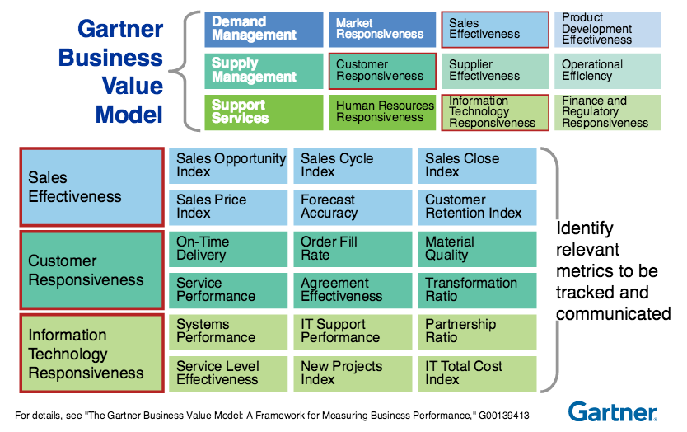

|  |  |  |
| --- | --- | --- |
| **Finance** | **Customer** | **Sales & Marketing** |
| Revenue, Revenue Growth Rate, Net Profit, Net Profit Margin | Net Promoter Score (BAIN)  Customer Retention Rate  Customer Profitability  Customer Life Time Value | Market Share  Market Growth Rate  Brand Equity  Cost per lead  Conversion Rate |
| **Operations** | **IT** | **Employee** |
| Operations Expense Ratio, Six Sigma Level, Capacity Utilization Rate, Order Fulfillment Cycle Time | IT Cost as a Percentage of Revenue?  IT Project Schedule Variance  Web Site Non-availability  Incident Resolution Index | Revenue Per Employee  Employee Satisfaction  **Employee Churn Rate**  Average Employee Tenure |

Good performance measurements

* Among the basic ingredients of a good collection are the following:
  + Measures should focus on **key factors.**
  + Measures should be a **mix of past, present, and future.**
  + Measures should **balance the needs of shareholders, employees, partners, suppliers, and other stakeholders.**
  + Measures should **start at the top and flow down to the bottom.**
  + Measures need to have **targets that are based on research and reality rather than arbitrary.**

# Utility goals

Increase system reliability and resiliency;

Replace aging infrastructure;

Modernize the energy grid to accommodate changing uses;

Enhance cyber and physical security;

Achieve environmental goals, including reducing greenhouse gas emissions;

Ensure public safety, resource adequacy, and diversity;

Promote long-term price stability while achieving the other objectives.

<http://www.edisonfoundation.net/iei/publications/Documents/Key_Trends_Driving_Change_Volume_III_FINAL.pdf>

SCE accelerated its residen-tial DR programs, setting the ambitious goal of enrolling 50,000 customers with smart thermostats across the Los Ange-les basin in just under two years to off-set 50 megawatts of demand

# SCE Customer choice

1.Res & Comm - Cost ability of a customer to reduce their net energy cost through IOU programs (ee, utility, usage, prosumer)

Advisory, equipment, rates

2.Comm - Ability to manage a customers profit and performance ratio based on energy cost and usage.

Advisory, equipment, rates

3.Transportation - Ability of a customer to access ev charging infrastructure (public ev charger density, average ev re-fuel time, average rate of charge )

Electric revenue/cost

4.Ability of a customer to choose and pay for fuel type / invest in GHG reduction /save the world

5. Developer – the ability of a developer to differentiate using clean energy

i.e. to keep rates low / lower rate with measurement. Or solar dissag. i.e. incease in accuracy

# Grid modernization

|  |  |  |  |
| --- | --- | --- | --- |
| need | driver | benefits | metrics |
| Ability to manage DER variation | DEG’s - volatility | Enbala to implement a  renewable firming application that con  -  nects some 2,000 DER assets—primar  -  ily HVAC and municipal water pump  -  ing stations—to the energy grid. | Beta-net load |
| Voltage reduction | overgen | DLVRs  help companies to increase energy  savings per circuit while lowering cus  -  tomer energy bills |  |
| Aging infrastructure |  |  | % below design standard  % meeting new design standard |
| Keep industry knowledge | Aging workforce X expect to retire in 10 years | Eg. Data systems |  |
| Too much or lack of information | New  Technologies, Automation | Enhanced  Reliability, Increased  Resiliency  Flexible & Responsive  Energy Grid Platform |  |
| Customer want control via DERs | Customer  Wants &  Needs | Empowered  Customers | Validate/ideas, |
| Integrate utility DER | Environmental  Goals | Reduced Carbon  Emissions | @ level X service |
|  | Growth in  Distributed  Energy Resources |  |  |
| Integrate customer DER | -must become a “plug-  and-play” platform / facilitate  Keving Payne  -Grid reinforcement  -managed load | Share costs – redesign rate.  Chk only if backfeed | Time-to-decision, time-to-funding, time-to-service @ level X service.  Change in voltage <= 0% on circuits with new DERs  (est. baseline)  Change in peak metrics <0%  %available hosting capacity vs. likely adoption |
| Visability | None on secondaries |  |  |
|  |  |  |  |

# Technology Initiatives

Data analytics: visibility, predictive maintenance, outage detect and restore, new services, next-gen grid energy management, DERs as a resource, tailored customer service, smart Cities

Vice President, Energy Technology and Analytics, Enterg

electric companies need to pursue flexibility as the foundation of their analytics strategy.

-Leveraging the **cloud**

OpenFMB and IEC-61850 to deploy wide services

-**Good governance**

data will be insecure or of low quality.

a common data dictionary, and flexible over-sight to share data securely while mask-

ing Personally Identifiable Information (PII) and enforcing user privileges.

electric companies will need to go a step further to build their own data science capability, which will become the nerve center for delivering value from

big data and for moving to a culture of data-driven decision making.

Makes sense:

* Customer Engagement
* Distribution Grid Management

Some advice from the field:

­

* Partner with a technology company on a proof-of-concept project targeted at a business imperative with the value of success clearly defined.
* Don’t be paralyzed by poor data quality—it will clean itself up quickly as it gets used.
* Move into production on a platform that can scale with a deployment plan that shows
* returns quickly and captures the full value over time.
* Reinvest some of the value to start the next project and build out an internal data science team.

global connected home market reaching $200 billion to $350 billion by 2025.

2

# Ideation

# Solutions

Georgia

Power used its AMI system to:

­eliminate unnecessary truck rolls to locations that already had been restored; and verify whether locations had power by “pinging” the AMI meter.

This also allowed us to reduce resto-ration times significant

[3]

https://www.mckinsey.com/business-functions/marketing-and-sales/our-insights/finding-the-right-digital-balance-in-b2b-customer-experience 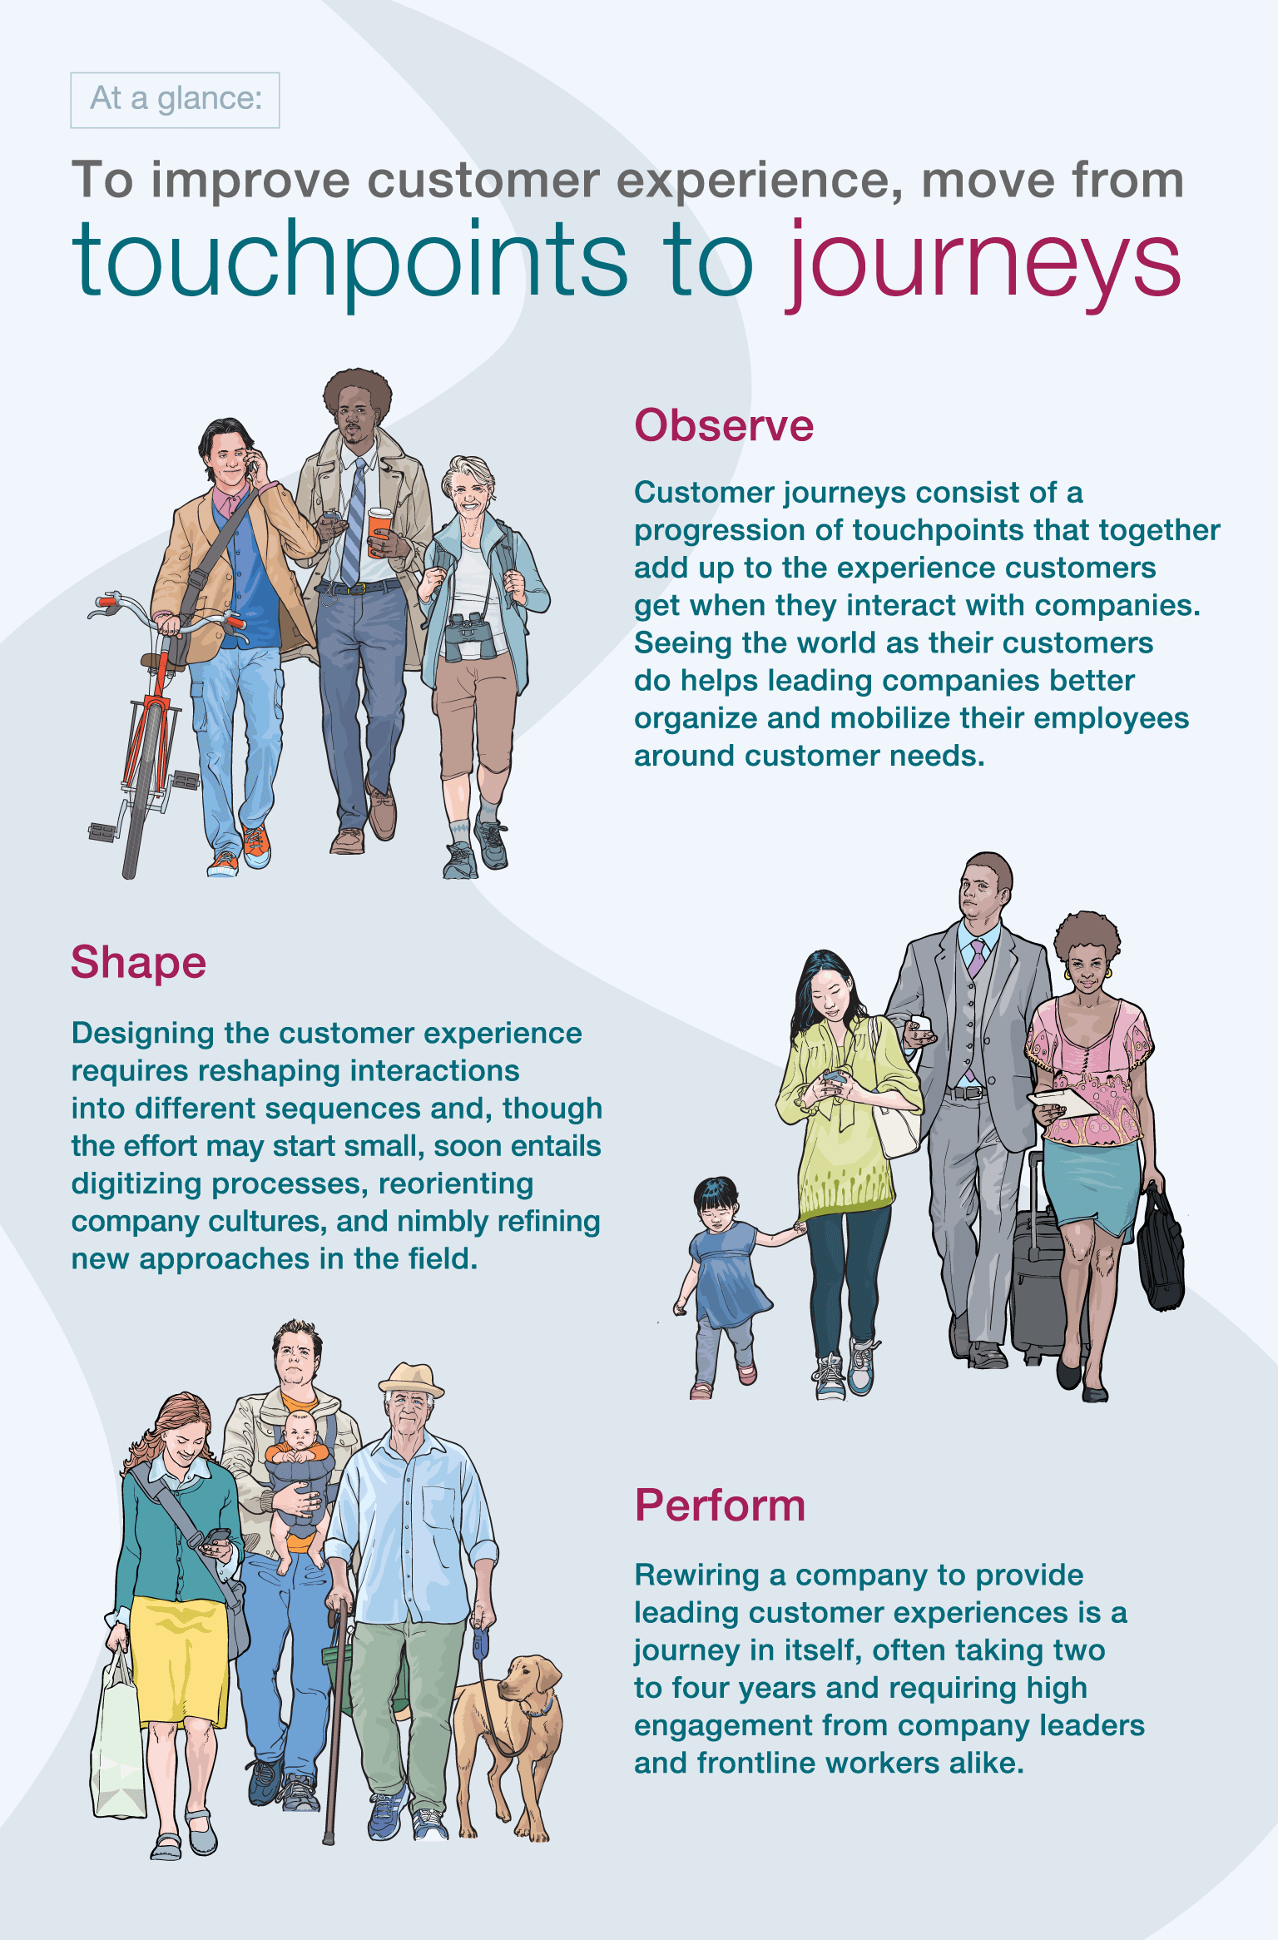

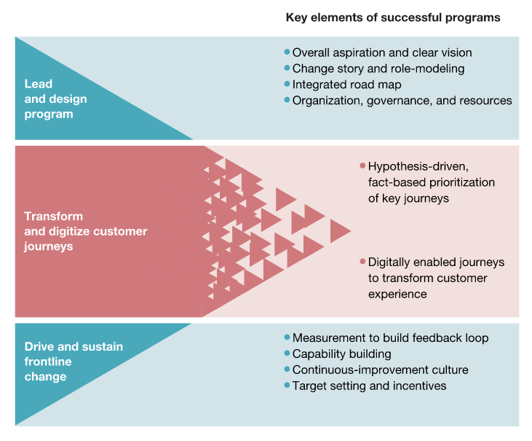

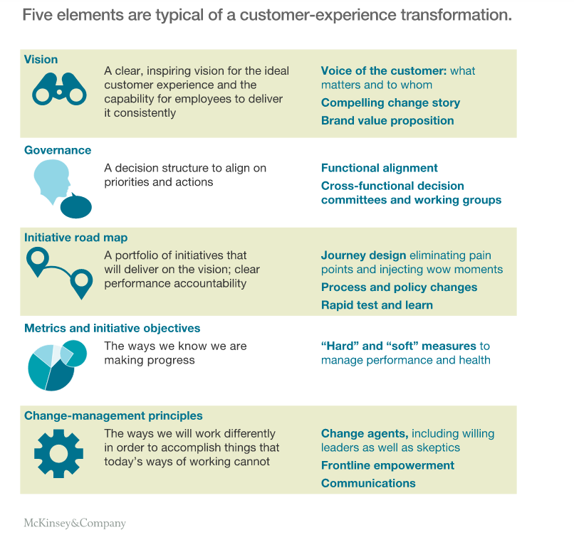

<https://www.mckinsey.com/business-functions/operations/our-insights/designing-and-starting-up-a-customer-experience-transformation>

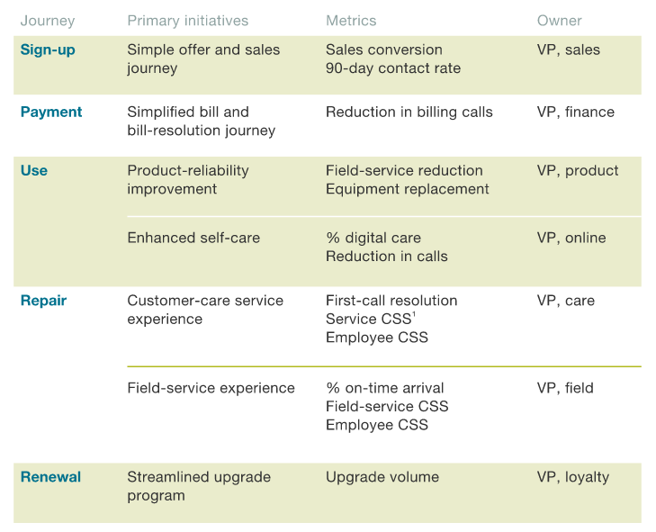

# In-flight

|  |  |  |
| --- | --- | --- |
| **Project** | **Problem/Opportunity** | **benefit** |
| Nodes | Customers are facing higher energy costs:  Der volatility base  CAISO ramping issue  Der impact on fleet gen | How much of load can contribute to increase flex |
| iga | Customers are facing Higher energy cost to customers  Higher risk of outage  / due to Lack of DER visibility for planning and |  |
| Sp5 | Opportunity to meet increased load demand for less | Identify to acquire non-wires for less  distribution asset deferral by leveraging customer  DER investments.  Identify and use strategic  deployment of DERs to provide outstanding, cost-effective reliability, particularly with increased penetration of variable  renewables such as solar  meet its aggressive greenhouse gas reduction goals; |
| Anomaly detection | Inability to forecast grid and customer equipment issues  - compare them to patterns we now understand are associated with  failure of electrical equipment, and  identify equipment that we can repair  or replace before it fails – Mckinsey  identify, filter, normalize -average, by time, and cluster | Decrease customer downtime  Decrease grid downtime (SAIDI)  Decrease equipment failure |
| Pred reliability | O&M operational efficiency | Lower O&M  Lower SAIDI |
| All hazards | Mitigating climate change impacts  -legal  -insurance cost  -stock price (retirees) | Increase ability to predict damage, resist and recover from substantial impact to  Grid |
| Safety | Physical impairment  Loss of life |  |
|  |  |  |

1. http://www.edisonfoundation.net/iei/publications/Documents/Key_Trends_Driving_Change_Volume_III_FINAL.pdf
2. http://www.edisonfoundation.net/iei/publications/Documents/The%20Edge_MayJune2018_PTP2018.pdf
3. P43 http://www.edisonfoundation.net/iei/publications/Documents/Key_Trends_Driving_Change_Volume_III_FINAL.pdf